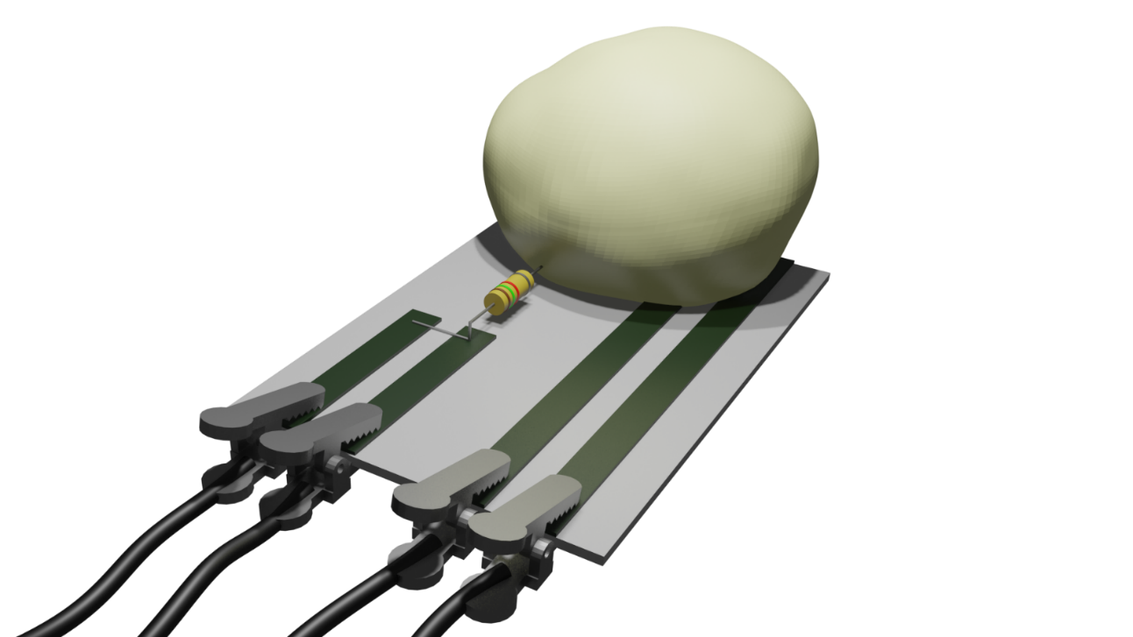
The SEMMELI project:

PAni, Bread & Breadboards



Introduction
In the current world, many action is eased by the presence of electrical devices but only 20% of these appliances is correctly recycled. Research efforts are focused on the development of an alternative to traditional electronics that should be low-cost, degradable, compostable, and made from environmentally nontoxic substances. As a candidate, cellulose is one of the most investigated raw materials, mainly because of high abundance on Earth, biocompatibility, porosity, high flexibility and light-weight (Khan, Abas, Kim, & Kim, 2016) (Luo & Huang, 2014). In addition, its low price (about 0.1 cent dm⁻²) (Tobjörk & Österbacka, 2011) and its recyclability make cellulose an economically very viable option (John, Mahadeva, & Kim, 2010) (Kanaparthi & Badhulika, 2017) (Tian, Qu, & Zeng, 2017). Despite its high surface resistivity at relative humidity of 20-40 % (typically 10¹¹-10¹⁵ Ω sq⁻¹) (Tobjörk & Österbacka, 2011), it can be used as support to produce conductive paper that can be exploited in a wide range of applications, including supercapacitors, microfluidic systems, diagnostic devices, actuators and sensors (Luo & Huang, 2014) (Kanaparthi & Badhulika, 2017) (Sanandiya, Vijay, Dimopoulou, Dritsas, & Fernandez, 2018) (Q. Wang et al., 2018).

Synthesis of the conductive cellulose

The synthesis of the cellulose that was used as active material for the sensors was carried out via an oxidative polymerization of Aniline on cellulose fibers in acidic media, thank to the addition of an oxidant as starter. Briefly, In a 1 L round bottom flask, 2.5 g of bare cellulose fibers were dispersed in demineralized water (250 mL) for 30 min; successively a solution made of 2.5 mL of aniline in 150 mL of 1.0 M hydrochloric acid (HCl) was added to the fiber suspension and stirred for 3 h at room temperature. In turn, the oxidative polymerization was carried out adding dropwise to the stirred suspension, previously cooled to 0 °C in an ice bath, a solution of 7 g of (NH₄)₂S₂O₈ dissolved in 200 mL of 1.0 M hydrochloric acid. After 24 h the coated fibers were filtered in a Buchner funnel and washed several times with 1.0 M citric acid solution. The conductive fibers were dried in air atmosphere for 24 h.
To obtain a 0.40 mm thickness sheet, 5 g of Cell/PANI fibers were added to 1.0 L of an acid solution (ca. pH 3.0, 25 wt% Al₂(SO₄)₃ in demineralized water) and stirred for 5 min, then the fibers were partially dried in a square sieve (21.0 cm x 14.8 cm size). Finally, the sheet was pressed at 50 bar pressures (P50 AXA manual hydraulic press) for 10 s.
Ragazzini I, Gualandi I, Selli S, et al. A simple and industrially scalable method for making a PANI-modified cellulose touch sensor. Carbohydr Polym. Published online 2020. doi:10.1016/j.carbpol.2020.117304
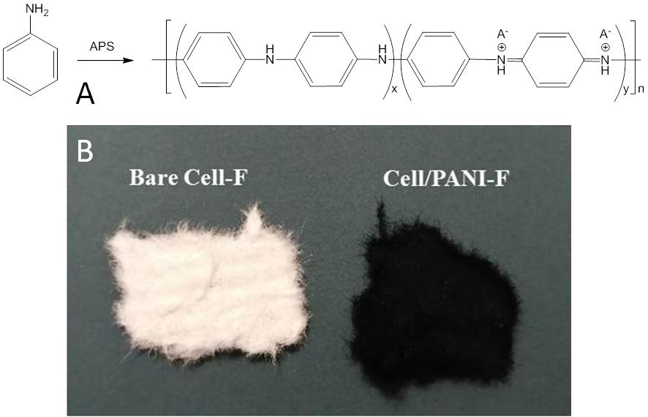

Electrical characterization of the Cellulose/PAni fibers

Cell/PANI resistance were measured with a Keysight B2902A source meter unit in a 4-line-probe configuration by exploiting a home-made holder that is composed by 4 parallel copper electrodes on a glass slide. In order to evaluate the reproducibility of the system, the effect of different morphology and the influence of the environmental condition during the real use, the electrical characterization was performed at different times on three different paper sheets at room temperature and balanced with the surrounding atmosphere. It was found that the conductivity of Cell/PANI sheets is 0.105 ± 0.004 S cm⁻¹ for a thickness of 0.40 mm. It is important to underline that our preparation method allows to obtain conductivity values higher (or similar, depending from the thickness) than those achievable by all the conductive papers presented in literature, as evident from the data reported in Table 1.
Table 1. Comparison of the conductivity of different samples based on PANI.
Material | Synthesis | Conductivity (S cm⁻¹) | Ref.
Cell/PANI-S | In situ synthesis on the cellulose pulp  (0.4 mm thickness) | 1.05 ± 0.04 10⁻¹ | This work
Rice pulp/PANI | In situ synthesis on the cellulose pulp | 2.5 10⁻⁵ | (Youssef, El-Samahy, & Abdel Rehim, 2012)
Pineapple fibers/PANI | In situ synthesis on the cellulose pulp | 3.0 10⁻⁴ | (S. I. A. Razak, N. F. A. Sharif, 2014)
Cellulose pulp/PANI | In situ synthesis on the cellulose pulp.  Chemiometric optimization | 1.5 10⁻² | (Sharifi, Zabihzadeh, & Ghorbani, 2018)
CA electrospun/PANI | In situ polymerization onto electrospun cellulose membrane | 1.0 10⁻¹ | (Baptista et al., 2018))
Cellulose/PANI | Dispersed Cellulose + PANI | 4.7 10⁻⁸ | (John et al., 2010)
Ink-jet printed PANI | Ink composed by PANI nanoparticles | 4.0 10⁻⁴ | (Ngamna et al., 2007)
Thin PANI film on filter paper | In situ polymerizzation on masked paper sheet | 1.0 10⁻³ | (Gao, Ota, Kiriya, Takei, & Javey, 2019)
PANI bulk |  | 1-5 | (Teo et al., 2019)

In order to clearly demonstrate the excellent conductivity of Cell/PANI-S, two 1.25 mm thick paper sheets were successfully used as wires to transport the current necessary to power a LED with an applied voltage of 2.0 V (Figure 5).
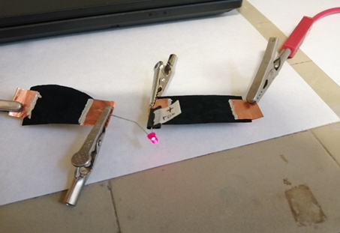

Formation of the sensors and electrical setup

The decided shape of the sensors to be tested was obtained simply cutting with scissors the sheets of modified cellulose. Stripes of the dimension of 5mm x 100 mm were sticked with vynil glue on an acetate sheets to have a non-conductive support. Sensors made of Copper tape of the same dimension were formed as reference electrodes.
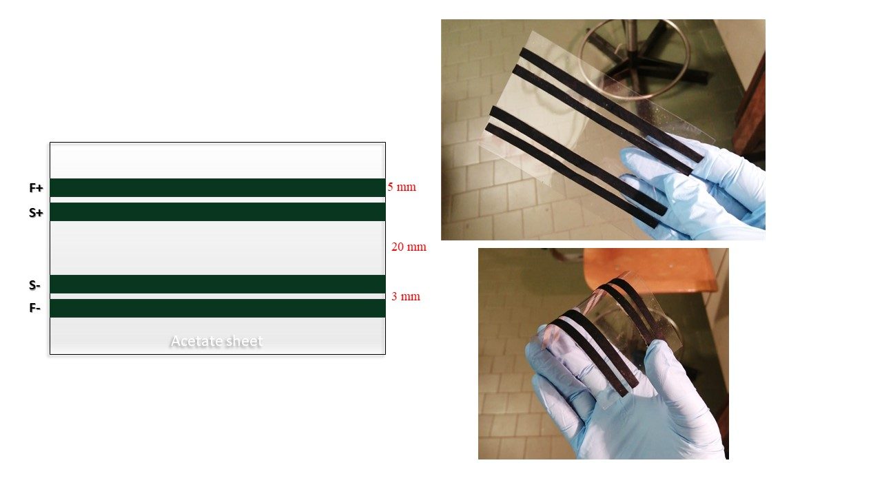
A 4-wires electrical impedance measurement was performed on dough samples of 70g via the EVAL-AD5940BIOZ Evaluation Board (Analog Devices Inc., Product Nbr.: EVAL-AD5940BIOZ). The evaluation board was connected to the Cu electrode and the PANI electrode via a custom made micro-USB to alligators clips cable (because this type of cable was not found on the market, and we needed to build them) following the schema on figure above (the signal name from the Eval board are F+, F-, S+, S-). For the measurements, four boards were used, two of them connected to the PANI electrodes, and two to the reference electrodes in Cu. For each batch, a PANI electrode and a Cu electrode were used for continuous measurement (the dough never changed), and for the other two, the dough was changed for each phase in the lievitation process.
(I need to check what was the thickness of the copper tape, as I don't remember it, and also I'm not sure on the name of the substrate)​
During the setup of the system, it was noticed, that the magnitude of the impedance [Ohm] was too low for our system (the system we are using is set up to use a R_{TIA} of 200 Ohm, that's the lowest R for the system without modification) as the value measured was lower than our R_{TIA} and therefore the system is not able to measure the impedance correctly. To solve this issue, a 1.5 kOhm resistor was added in series to raise the measured impedance magnitude. This added resistor will be then taken out in the data analysis part, to recuperate the real dough impedance value.

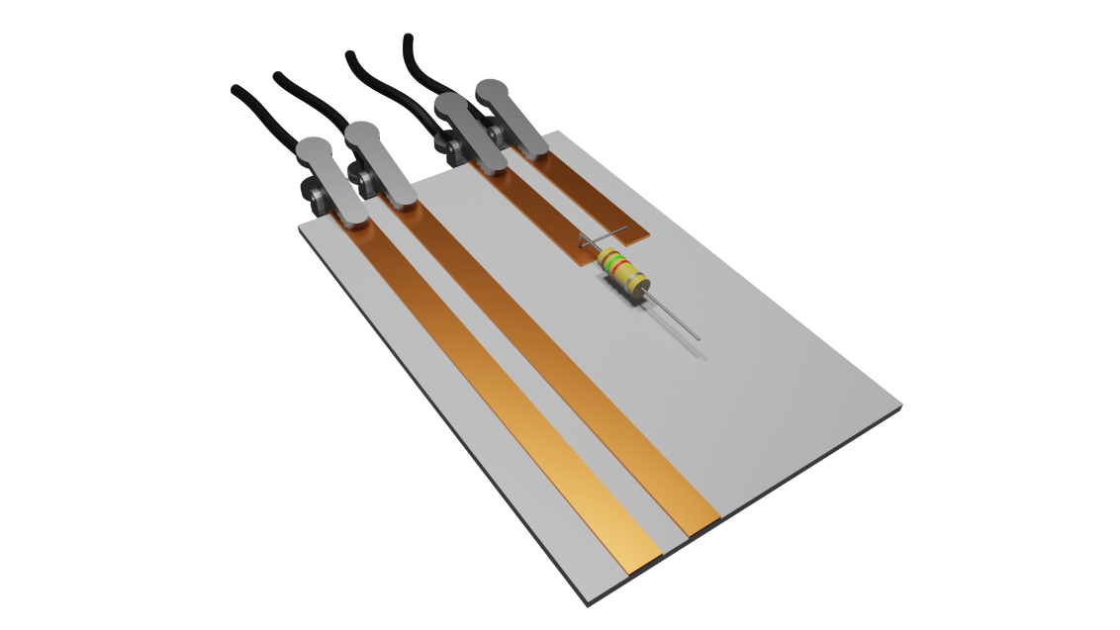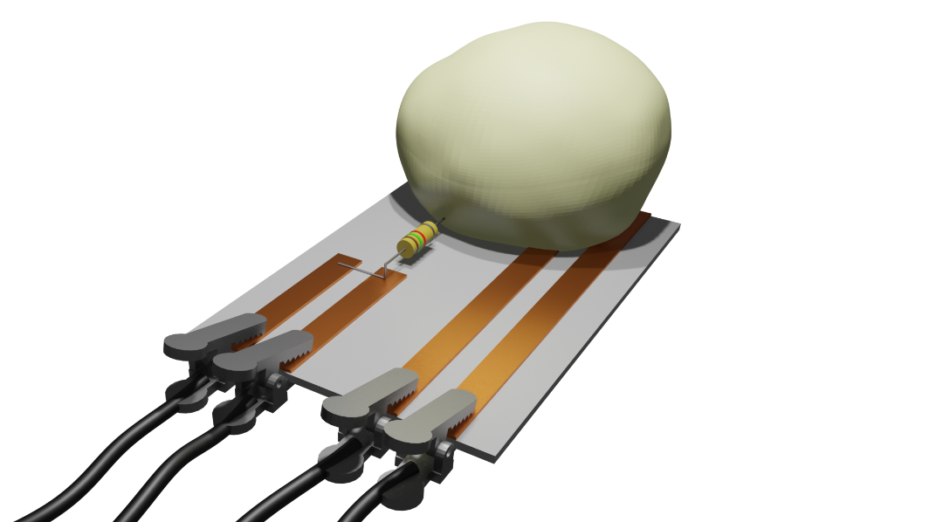

The AD5940 will measure the current [A] and the voltage [V] on the dough and the software on the evaluation board will calculate the impedance magnitude [Ohm] and phase [deg] based on the read values and the internal component of the chip itself (R_{TIA} resistor).
$$V_{Mag}= \sqrt{{Re\left(V_{DFT}\right)}^{2}+ {Im\left(V_{DFT}\right)}^{2}}$$
$$V_{Phase}= atan2\left(-Im\left(V_{DFT}\right),Re\left(V_{DFT}\right)\right)$$
$$I_{Mag}= \sqrt{{Re\left(I_{DFT}\right)}^{2}+ {Im\left(I_{DFT}\right)}^{2}}$$
$$I_{Phase}= atan2\left(-Im\left(I_{DFT}\right),Re\left(I_{DFT}\right)\right)$$
$$V_{Mag_result}= \frac{V_{Mag}}{I_{Mag}}∙R_{TIA_Mag}$$
$$V_{Phase_result}= V_{Phase}- I_{Phase}+ R_{TIA_Phase}$$
Where: V_{DFT} is the Discrete Fourier Transform of the measured voltage,
I_{DFT} is the Discrete Fourier Transform of the measured current,
R_{TIA_Mag} is the measured resistance magnitude of the R_{TIA} gain resistor
R_{TIA_Phase} is the measured phase of the R_{TIA} gain resistor

The software used on the EVAL-AD5940BIOZ board is a modified version of the example code AD5940_BIA (https://github.com/analogdevicesinc/ad5940-examples/tree/master/examples/AD5940_BIA). The code was modified to allow to set how much time needed to pass between each measurement (in our case 10 s) and also the frequency at which the measurement is made was changed from the default 50 kHz to 1 kHz. Moreover, to allow an easier recording of the data generated by the evaluation Board, a Python code (using python 3.7 and tested on version 3.7 and 3.9) was created that read the serial signal sent by each card and saved it in a CSV file to be easily used later for the data analysis. Lastly, a computer with 4 USB ports (one for each evaluation board) or a USB-Hub with 4 ports it's needed to connect the four systems to the PC on which the python code for the recording of the data will run.
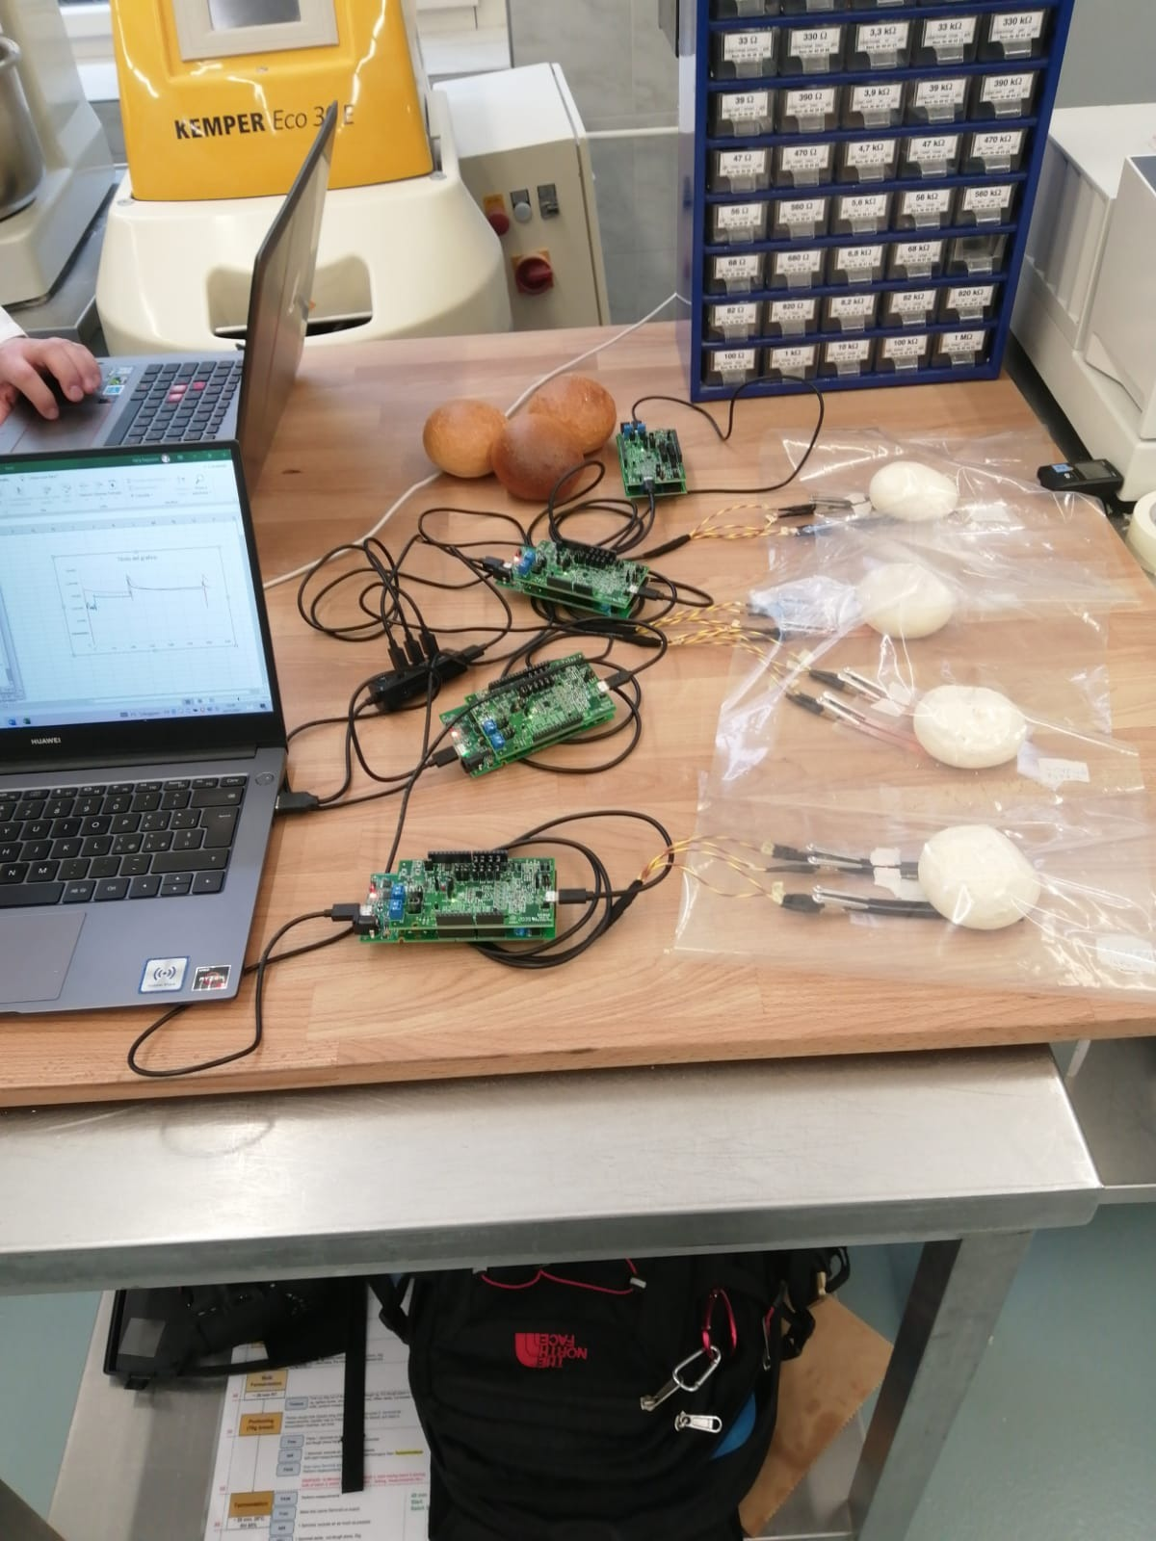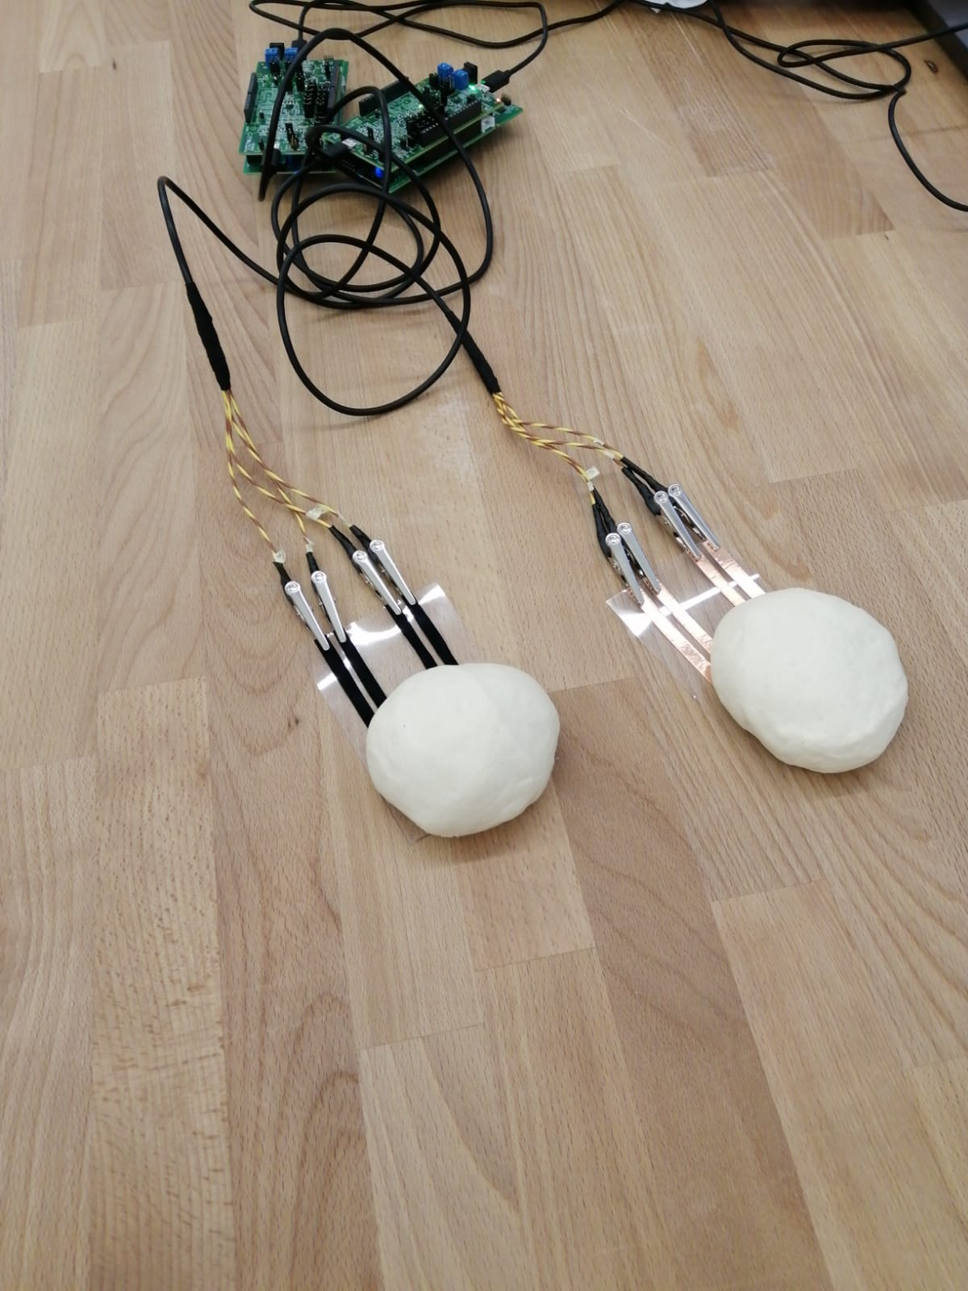
Bread recipes
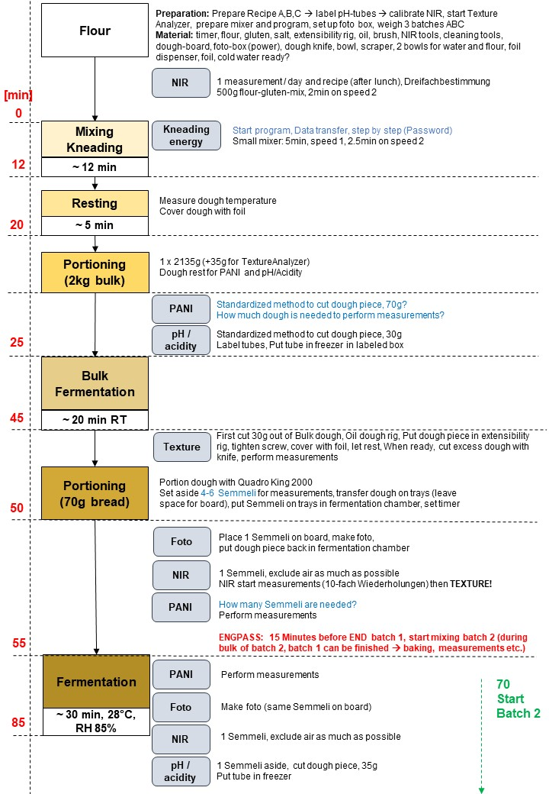

Materials

All chemicals and solvents are ACS reagent grade, were purchased from commercial vendors and used directly unless otherwise stated. Sulfuric acid (H₂SO₄, 95.0-98.0%), ammonium persulfate [(NH₄)₂S₂O₈), ≥ 98%, APS] and aniline (≥ 99%), were purchased from Sigma-Aldrich (now Merck KGaA, Darmstadt, Germany); aniline was distilled under nitrogen prior to use. Hydrocloric acid (HCl, ≥ 37%) was purchased from VWR Chemicals (Vienna, Austria); a solution of ca. 25 wt% of Al₂(SO₄)₃ in water (commercial name FLOCLINE S8C) was purchased from Bio-Line s.r.l. (Milano, Italy). Bare cellulose fibers (pine tree long fiber with sulfate treatment) were kindly provided by Cromatos s.r.l. (Forlì, Italy). Universal pH paper test (Jovitec) was used for the pH measures.

Data treatment
Every batch measure was treated to obtain two important values:
- The average value of magnitude (Ohm), when the response of the sensor is stable;
- The τ value, that is the speed of decreasing of the curves. It was obtained fitting every step with an exponential curve (EXP.dec) and calculating the tangent in the first part. The program Origin pro 8.5 (that I used for the fitting), gives that value directly in the output table.
Recipe | Repetitions
A (gluten free) | A122m
 | A222a
 | A523m
 | A723a
 | A923a
 | A1124m
 | A1324a
B (more gluten in the flour) | B322a
 | B423m
 | B623m
 | B823a
 | B1024m
 | B1224m
 | B1424a

All the calculations were made for the PANI sensors and for the reference. If the fitting did not converge, it was omitted.
We changed the PANI sensor for every batch, the reference sensor every day of measurements. Everytime we perform the measurement, the additional resistance was fixed on the sensor with paper tape and checked during the measurement (the magnitude signal had to be more than 1500 Ohm to measure correctly).
The phase output of the impedance measurements was more or less the same everytime, so we considered only the Magnitude values for the data treatment.
For every batch, we performed a measurement divided in 3 steps (bulk fermentation, portioning, after fermentation) and a continuous measurement. For batches A1324a and B1224m we performed also a “mistake of production” test.
Summary
Reference fitting for recipe A (not continuous) pag. 11
PANI fitting for recipe A (not continuous) pag 15
Comparison of recipes A (not continuous) pag 19
Magnitude trend of sensors for recipe A pag 20
Continuous measurements for recipe A pag 21
Reference fitting for recipe B (not continuous) pag. 24
PANI fitting for recipe B (not continuous) pag 28
Comparison of recipes B (not continuous) pag 32
Magnitude trend of sensors for recipe B pag 33
Continuous measurements for recipe B pag 34
Mistakes of production pag 37

Reference fitting A122m
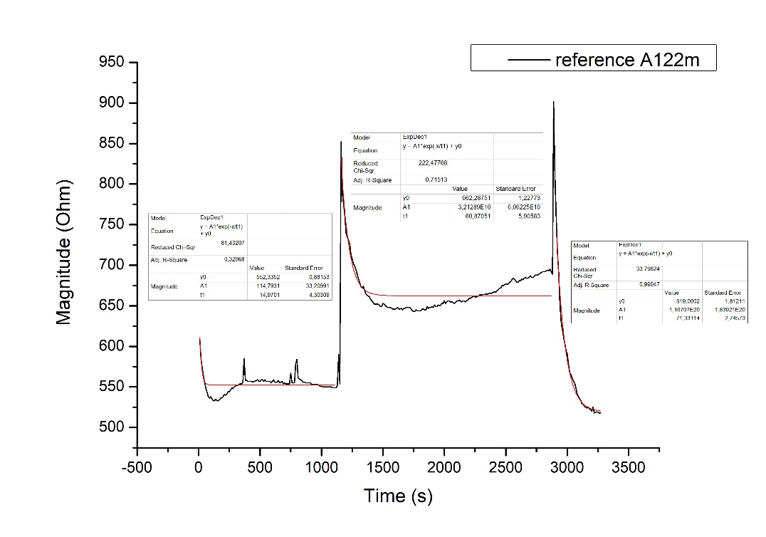
$$τ_{1}$$ | 15
$$τ_{2}$$ | 61
$$τ_{3}$$ | 71

Reference fitting A222a
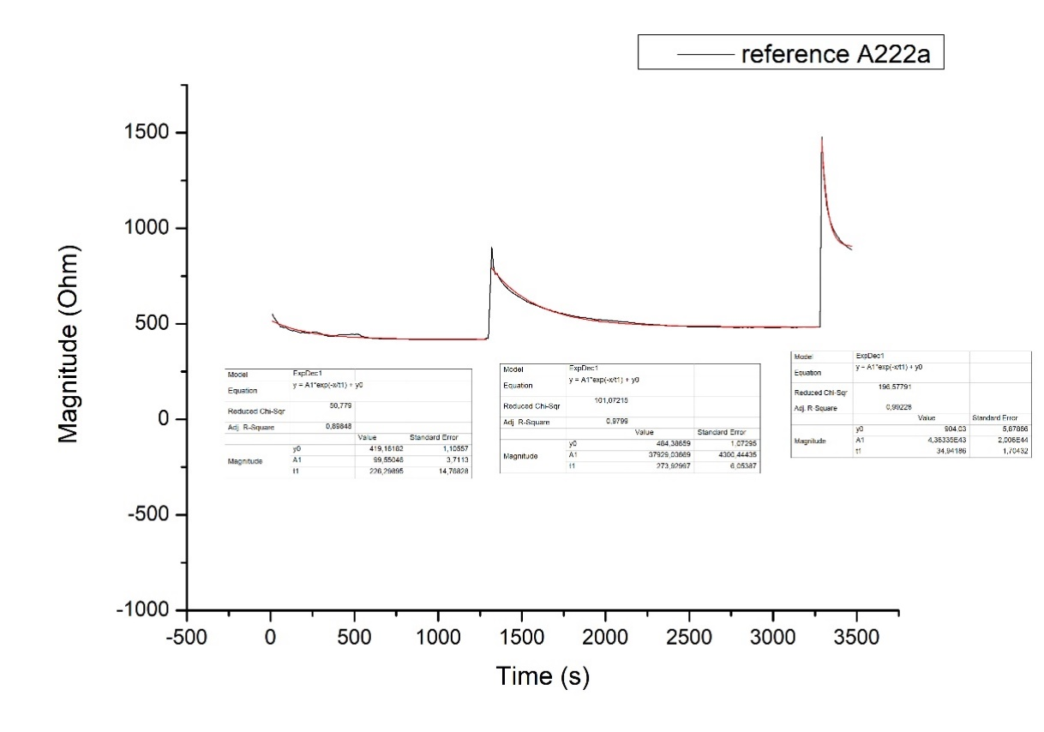
$$τ_{1}$$ | 226
$$τ_{2}$$ | 273
$$τ_{3}$$ | 34
Reference fitting A523m
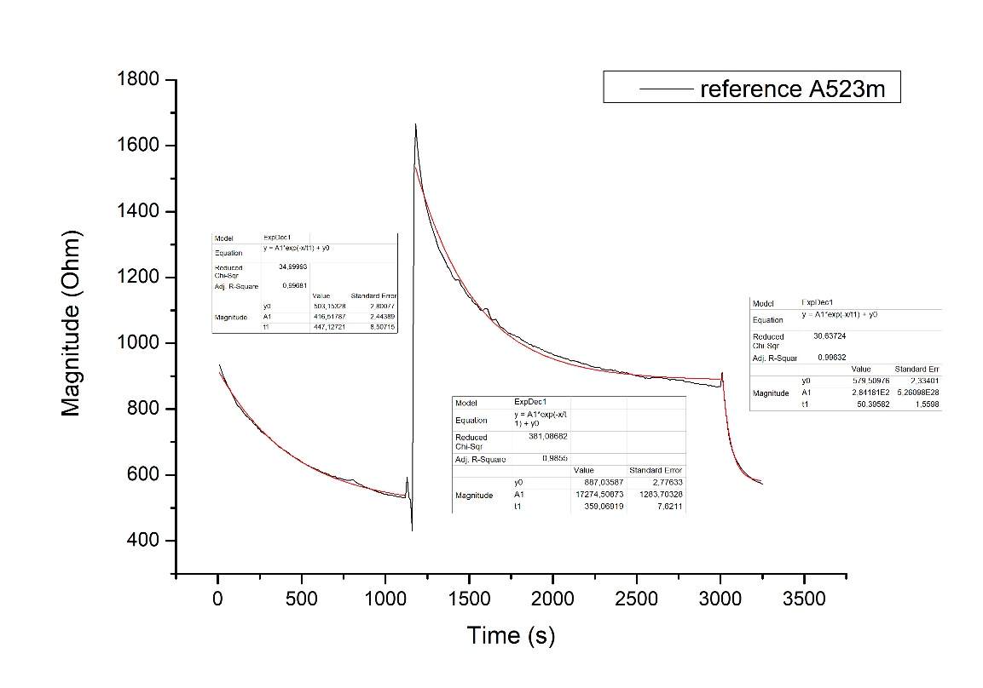
$$τ_{1}$$ | 447
$$τ_{2}$$ | 359
$$τ_{3}$$ | 50

Reference fitting A723a
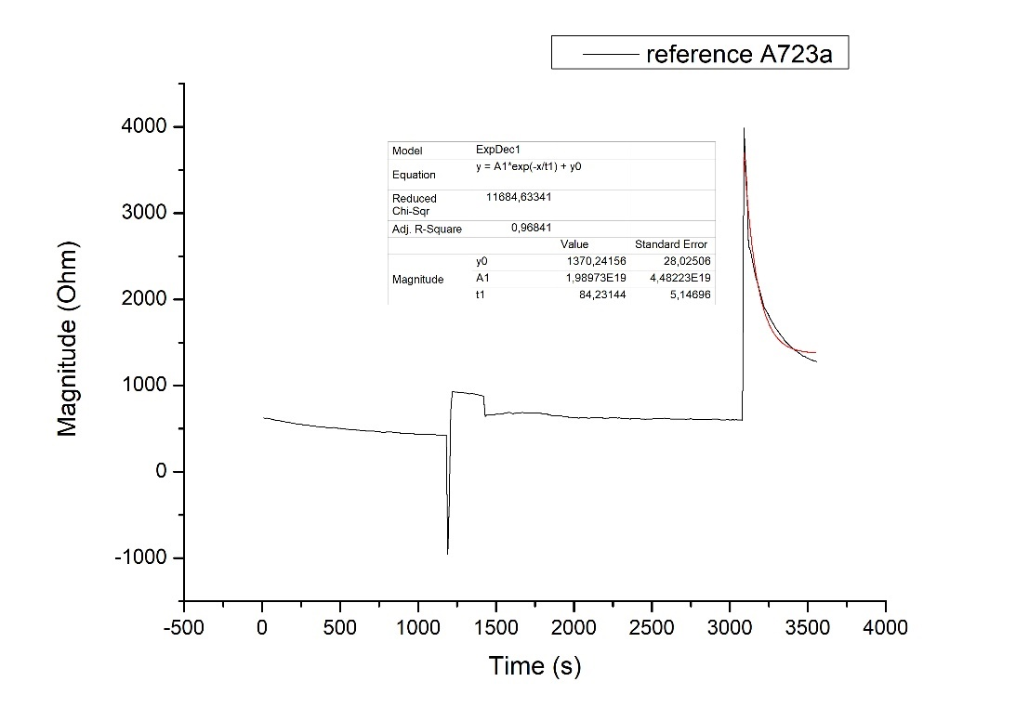
$$τ_{1}$$ | --
$$τ_{2}$$ | --
$$τ_{3}$$ | 84
Reference fitting A923a
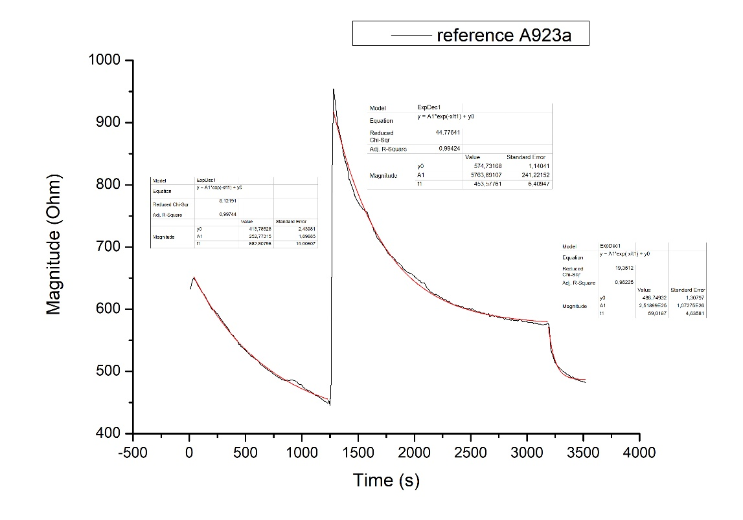
$$τ_{1}$$ | 683
$$τ_{2}$$ | 454
$$τ_{3}$$ | 59

Reference fitting A1124m
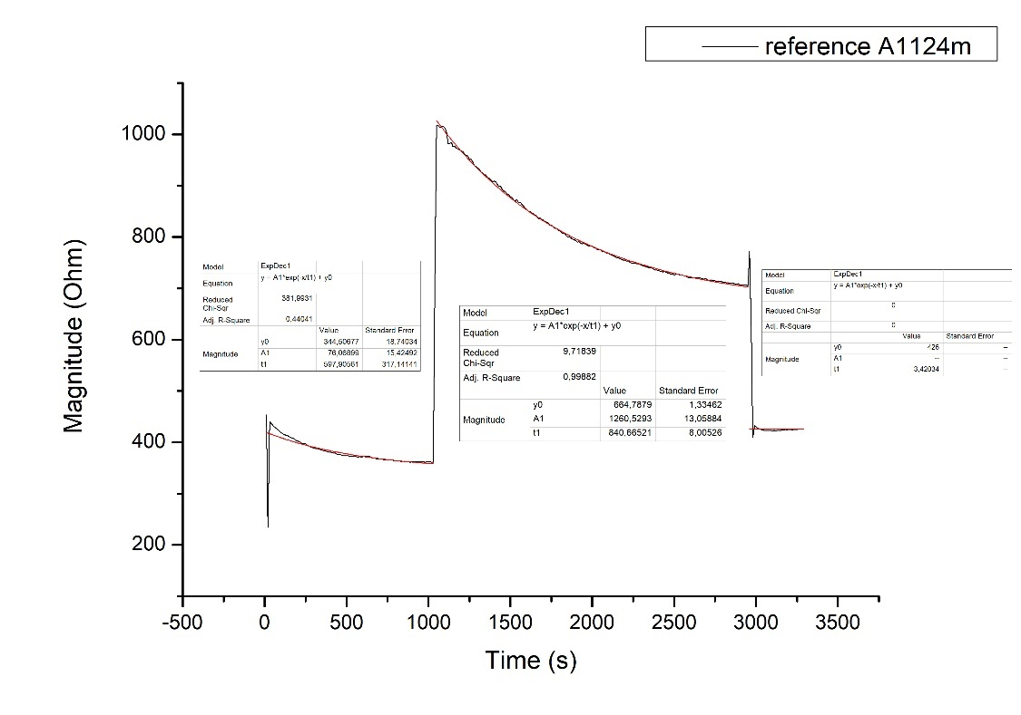
$$τ_{1}$$ | 597
$$τ_{2}$$ | 840
$$τ_{3}$$ | 3
Reference fitting A1324a
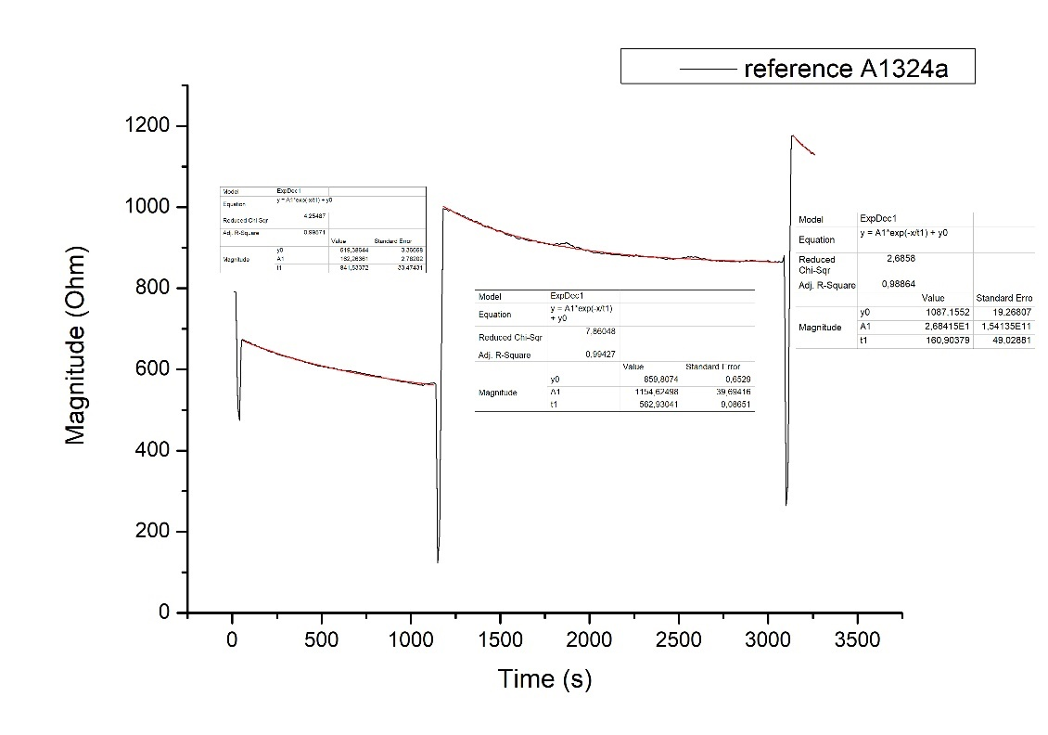
$$τ_{1}$$ | 841
$$τ_{2}$$ | 563
$$τ_{3}$$ | 161

Summary
$$τ_{1}$$ | 468 ± 305
$$τ_{2}$$ | 425 ± 265
$$τ_{3}$$ | 66 ± 49

PANI sensor fitting A122m
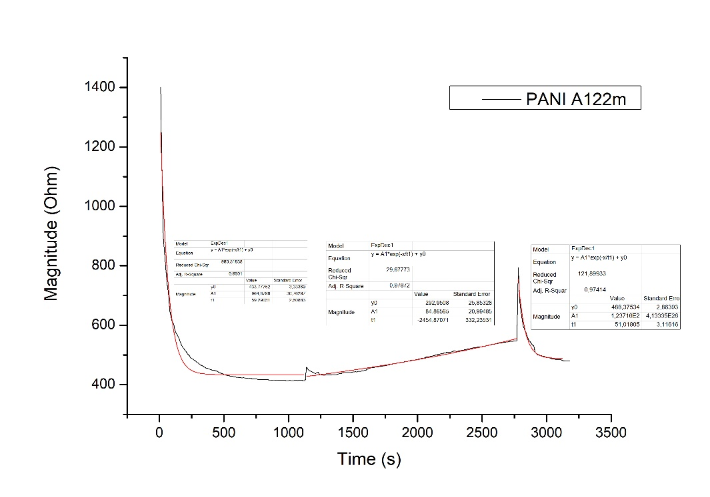
$$τ_{1}$$ | 59
$$τ_{2}$$ | --
$$τ_{3}$$ | 51

PANI sensor fitting A222a
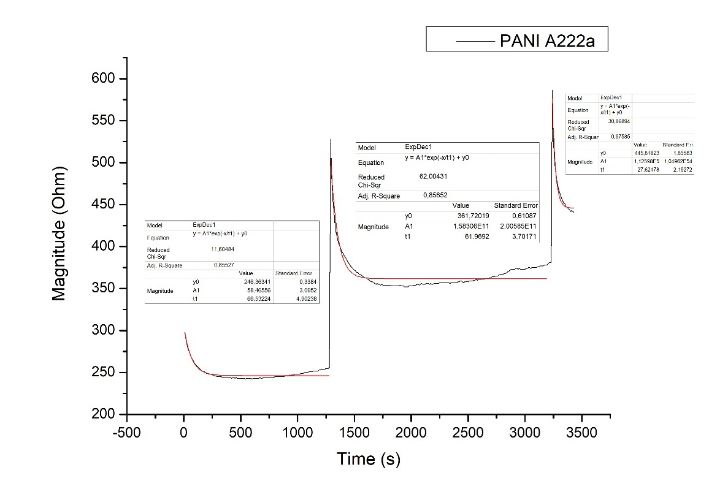
$$τ_{1}$$ | 66
$$τ_{2}$$ | 62
$$τ_{3}$$ | 28

PANI sensor fitting A523m
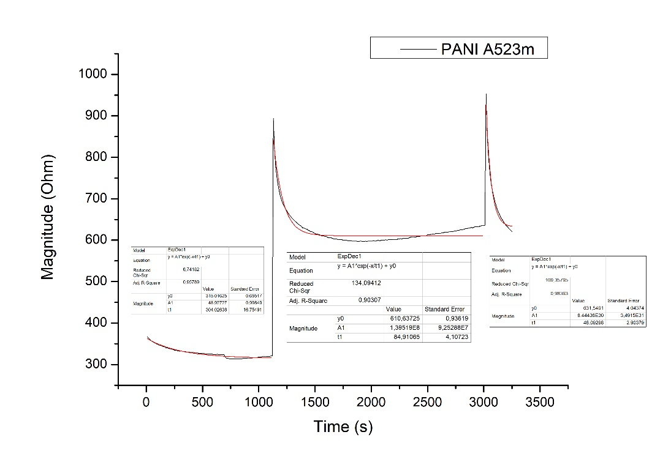
$$τ_{1}$$ | 304
$$τ_{2}$$ | 84
$$τ_{3}$$ | 46

PANI sensor fitting A723a
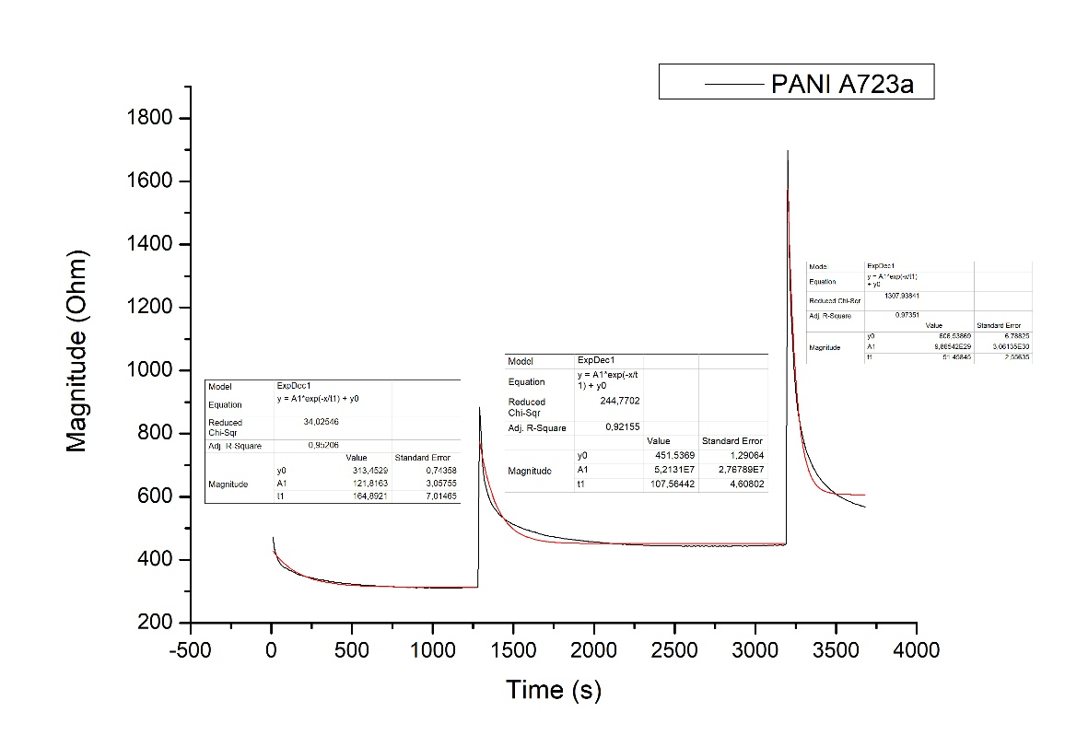
$$τ_{1}$$ | 165
$$τ_{2}$$ | 107
$$τ_{3}$$ | 51

PANI sensor fitting A923a
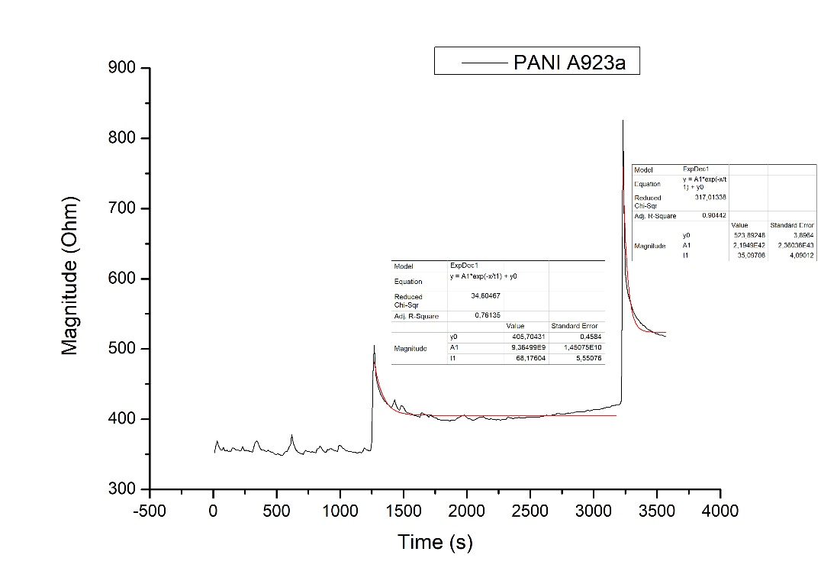
$$τ_{1}$$ | --
$$τ_{2}$$ | 68
$$τ_{3}$$ | 35

PANI sensor fitting A1124m
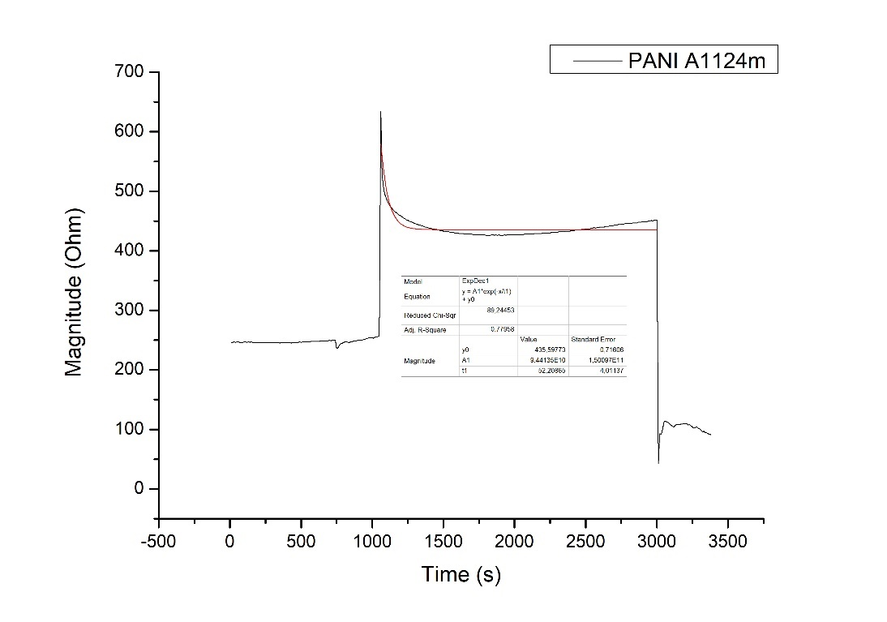
$$τ_{1}$$ | --
$$τ_{2}$$ | 52
$$τ_{3}$$ | --

PANI sensor fitting A1324a
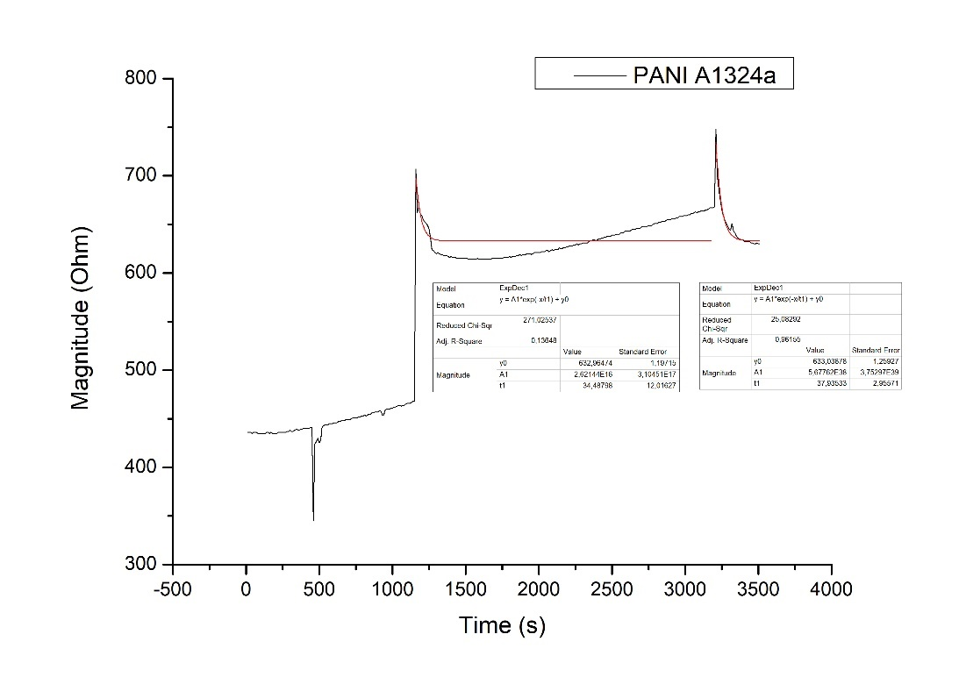
$$τ_{1}$$ | --
$$τ_{2}$$ | 34
$$τ_{3}$$ | 38

Summary
$$τ_{1}$$ | 148 ± 114
$$τ_{2}$$ | 68 ± 25
$$τ_{3}$$ | 41 ± 9

Comparison Recipes A
A122m A222a
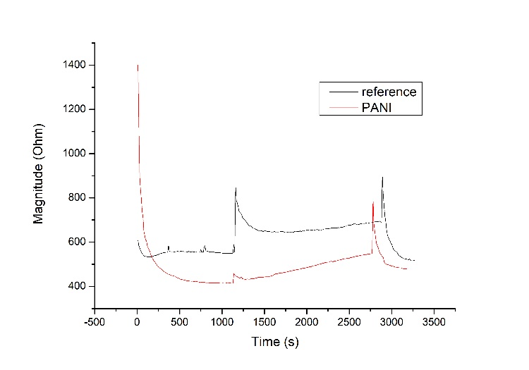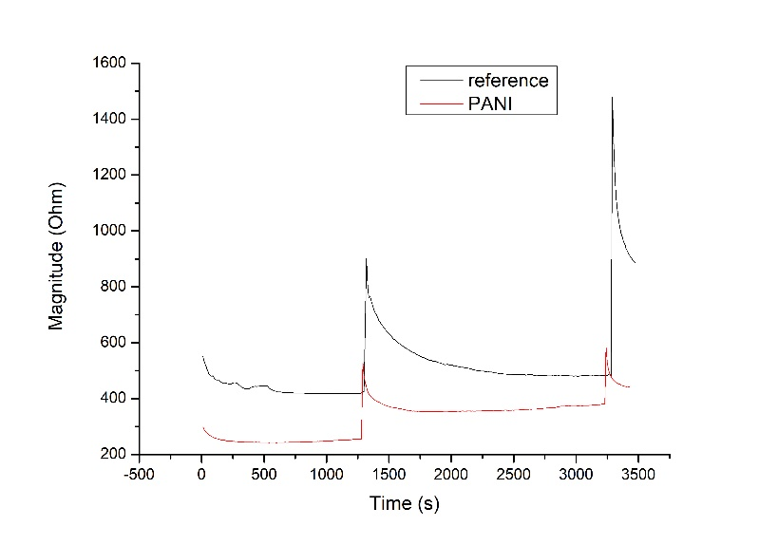
A523m A723A
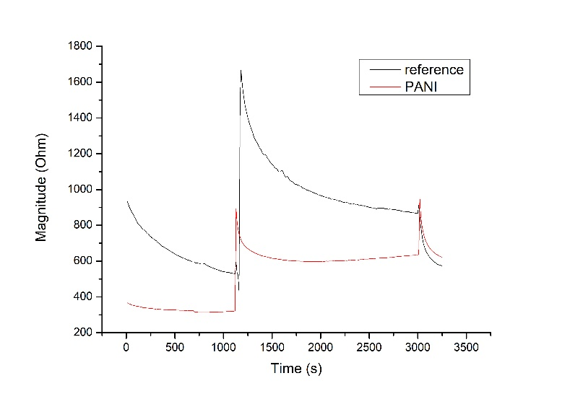
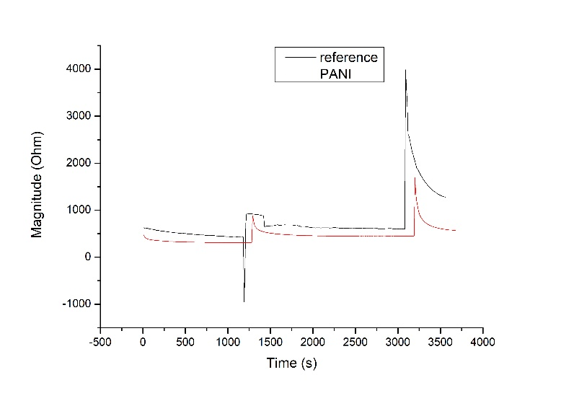
A923a A1124m
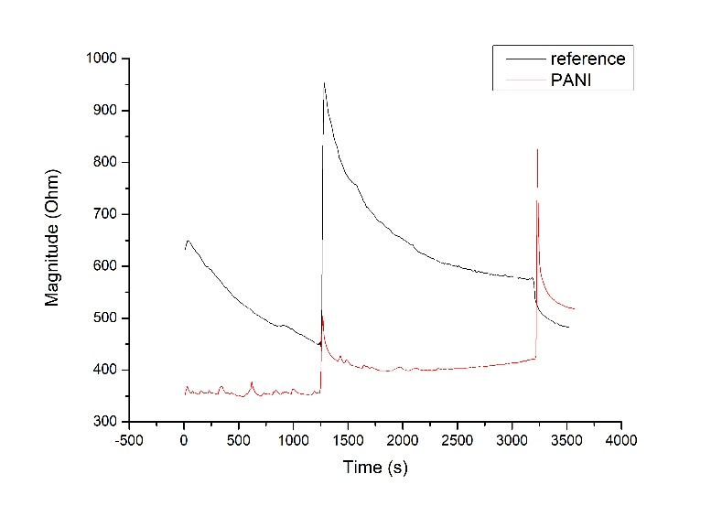
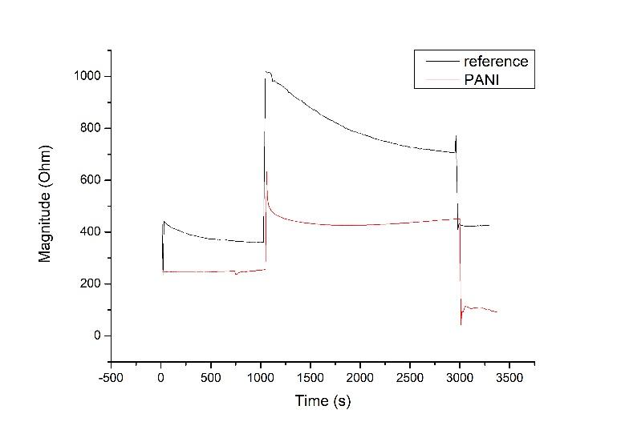

A1324a
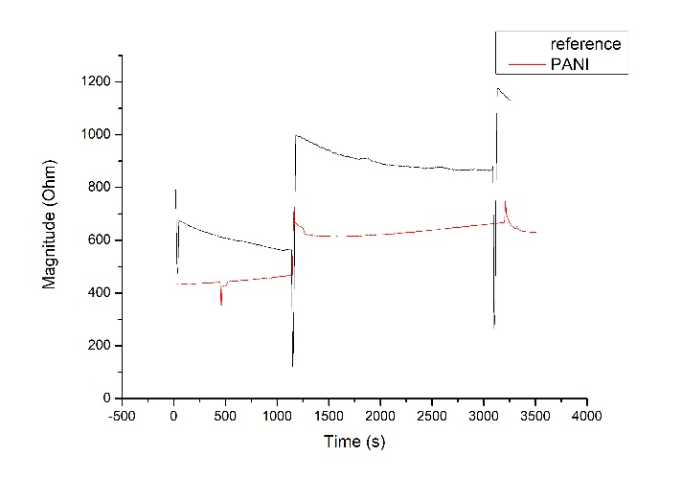

Magnitude trend of sensors for recipe A
This graph is obtained calculating the average of every linear part of the graphs corresponding of a stable signal for the impedance measurements. BF: bulk fermentation, P: portioning, AF: after fermentation.

Recipe | Bulk fermentation |  | Portioning |  | After fermentation
 | reference | PANI | reference | PANI | reference | PANI
A122m | 556 ± 6 | 416 ± 2 | 668 ± 25 | 493 ± 34 | 522 ± 3 | 484 ± 4
A222a | 424 ± 9 | 247 ± 4 | 489 ± 10 | 362 ± 8 | 890 ±4 | 442 ± 1
A523m | 539 ± 6 | 318 ± 2 | 886 ± 10 | 614 ± 11 | 575 ± 3 | 624 ± 5
A723a | 443 ± 12 | 311 ± 1 | 610 ± 5 | 444 ± 1 | 1283 ± 5 | 569 ± 2
A923a | 461 ± 9 | 356 ± 3 | 581 ± 5 | 409 ± 6 | 483 ± 1 | 518 ± 1
A1124m | 364 ± 2 | 248 ± 4 | 717 ± 6 | 438 ± 8 | 425 ± 1 | 103 ± 6
A1324a | 564 ± 2 | 461 ± 4 | 867 ± 2 | 658 ± 5 | 1131 ± 3 | 630 ± 1

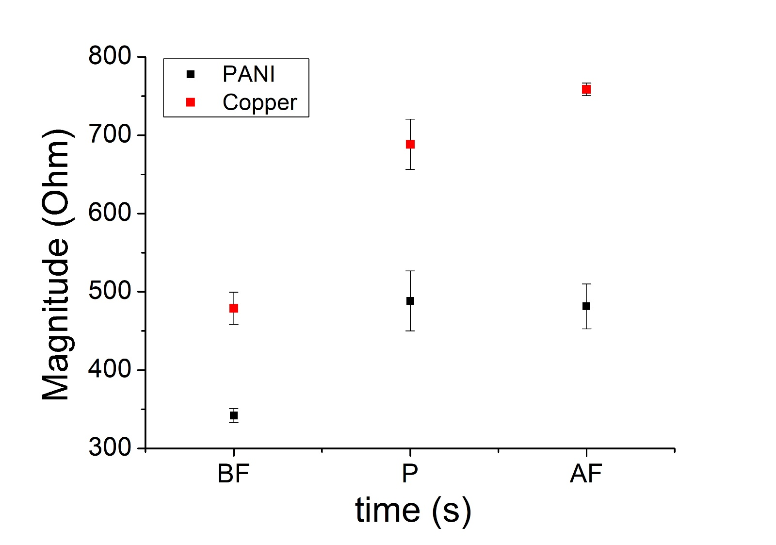

Continuous measurements

We peformed also continuous measurements on every recipe. Briefly, we put on 2 sensors (PANI sensor and the reference) a dough during the first step (bulk portioning), and left them for all the fermentation period until the dough has to be put in the oven, measuring continuously the impedance. Also in these cases, every curve was fitted with an exponential fitting to calculate the response time of the respective sensor. The results that we obtained are described below.

A122m A222a
τreference | 228
τPANI | 51
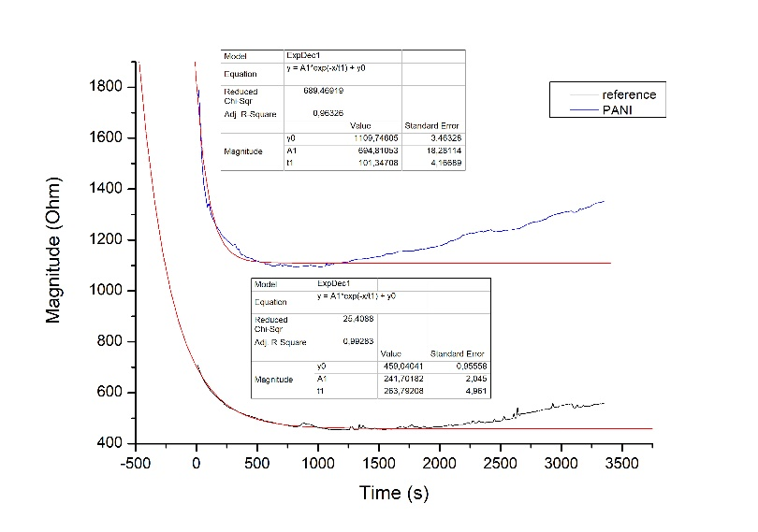
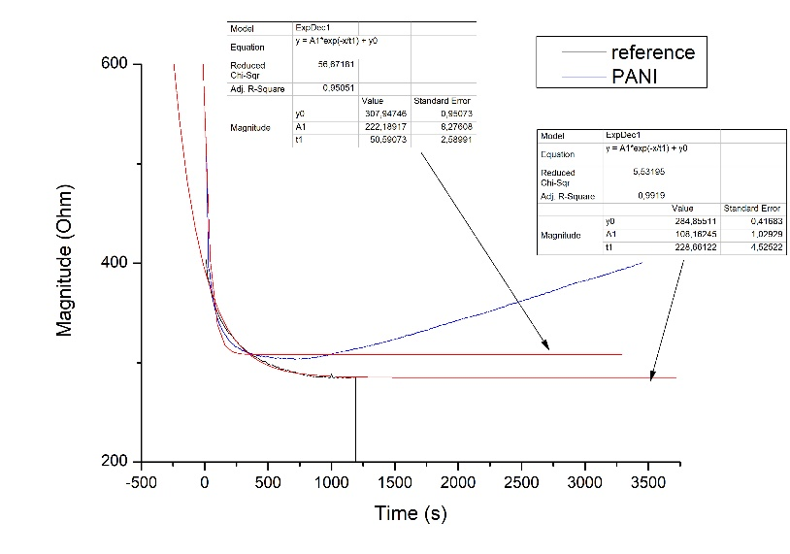
τreference | 264
τPANI | 101

Note: in the analysis of the recipe A222a, the reference had some connection problems during the study, the fitting is only an extimation of the first 1000 s of analysis.
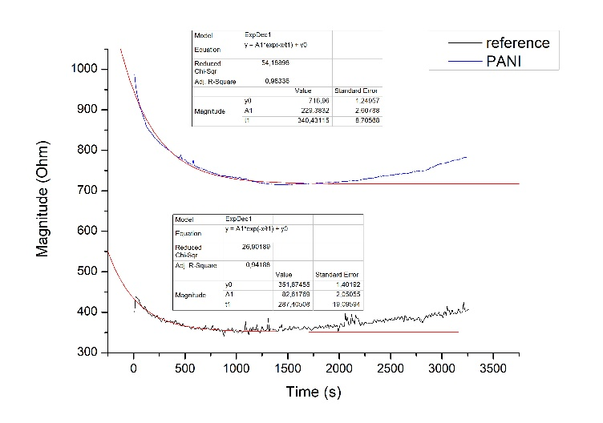
A523m A723a
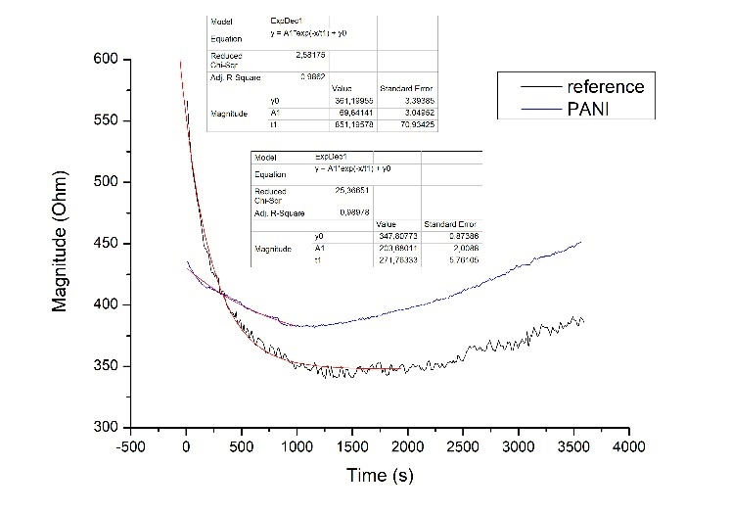
τreference | 287
τPANI | 340
τreference | 271
τPANI | 651

A923a A1124m
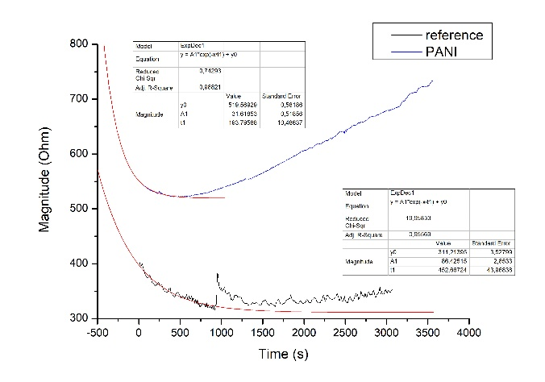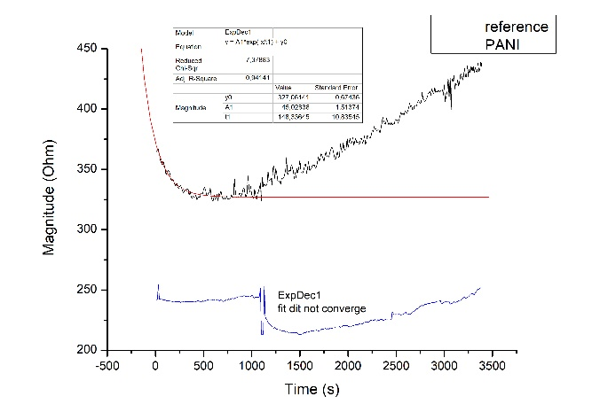
τreference | 452
τPANI | 193
τreference | 148
τPANI | --

Note: in the analysis of the recipe A1124m, the PANI sensor had some connection problems during the study, the fitting is not converging and the signal is minor than in other cases, probably the sensor has some problems.
A1324a
τreference | 290 ± 99
τPANI | 267 ± 241
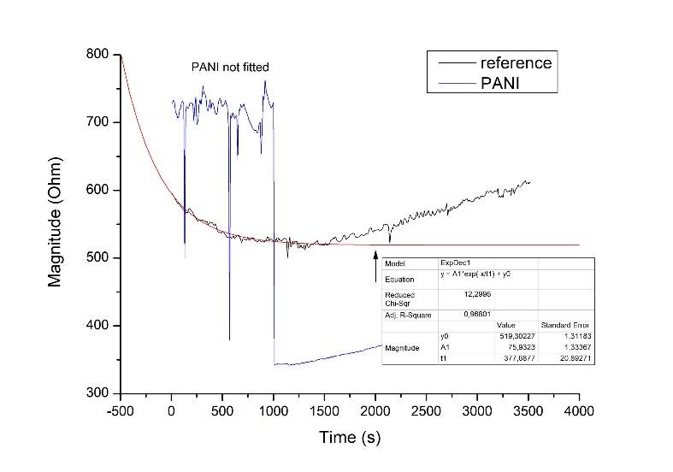
Summary
τreference | 378
τPANI | --

Note:in the analysis of the recipe A1324a, the PANI sensor had some connection problems during the study, the fitting is not converging.

Reference fitting B322a
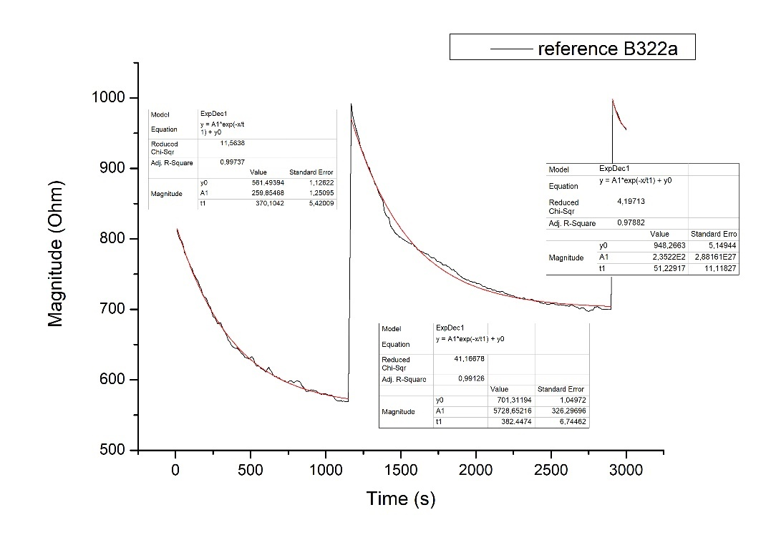
$$τ_{1}$$ | 370
$$τ_{2}$$ | 382
$$τ_{3}$$ | 51

Reference fitting B423m
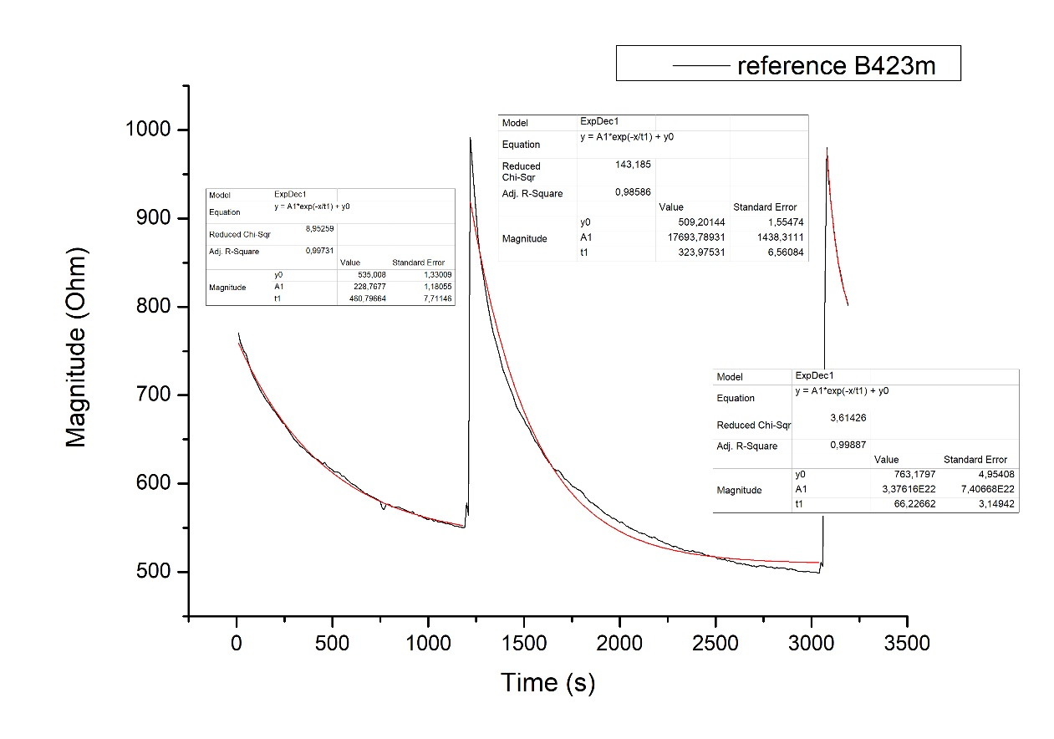
$$τ_{1}$$ | 461
$$τ_{2}$$ | 324
$$τ_{3}$$ | 66

Reference fitting B623m
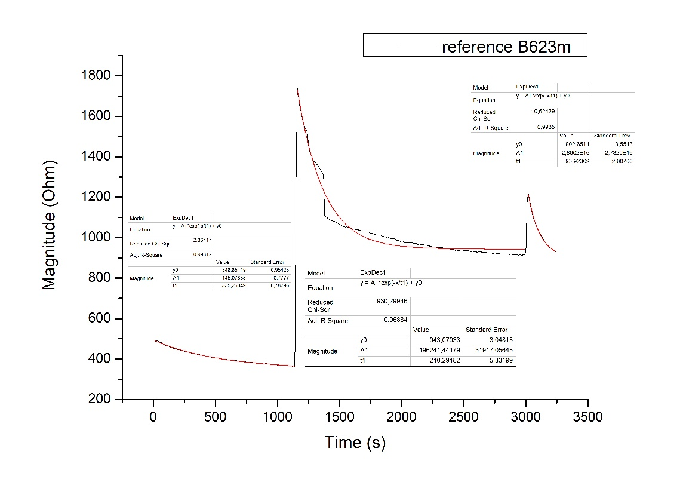
$$τ_{1}$$ | 535
$$τ_{2}$$ | 210
$$τ_{3}$$ | 94

Reference fitting B823a
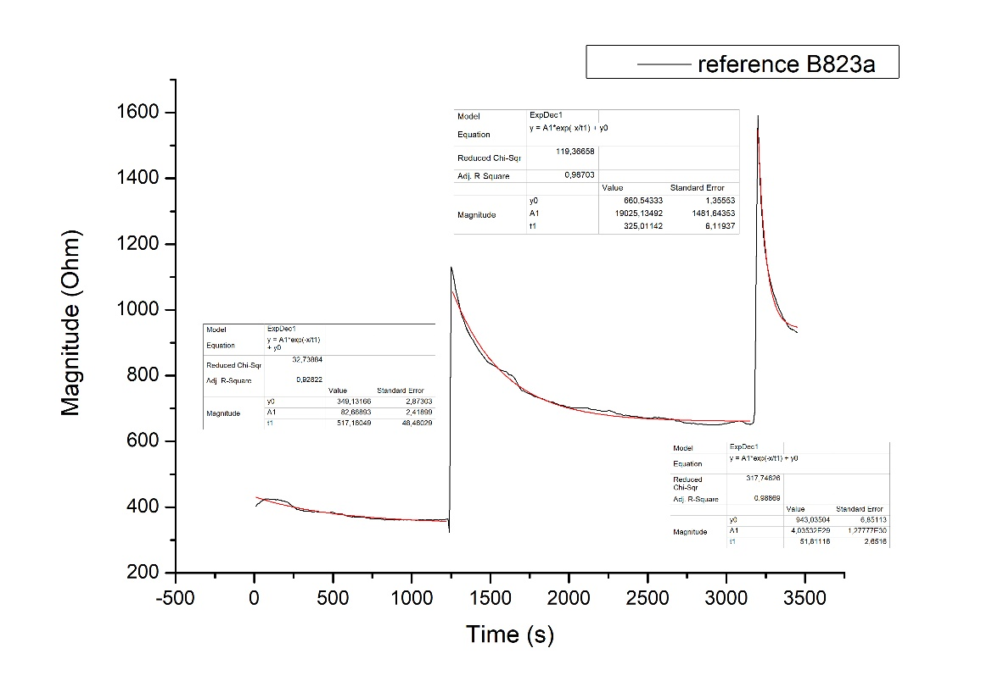
$$τ_{1}$$ | 517
$$τ_{2}$$ | 325
$$τ_{3}$$ | 52

Reference fitting B1024m
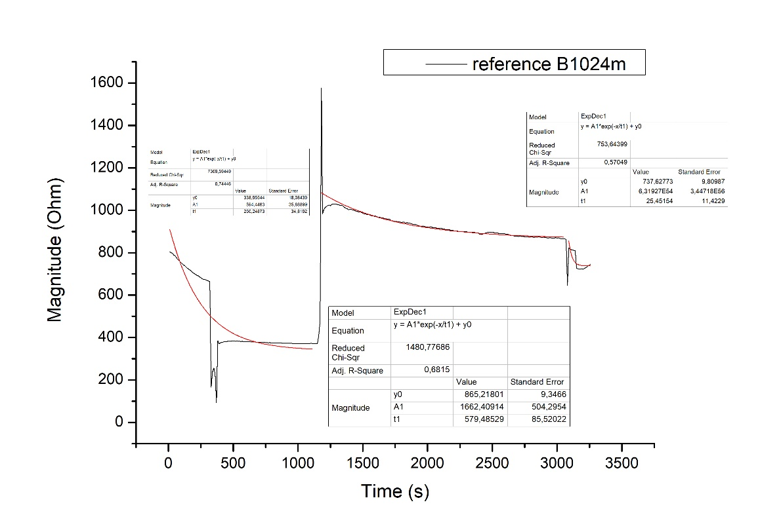
$$τ_{1}$$ | 250
$$τ_{2}$$ | 579
$$τ_{3}$$ | 25

Reference fitting B1224m
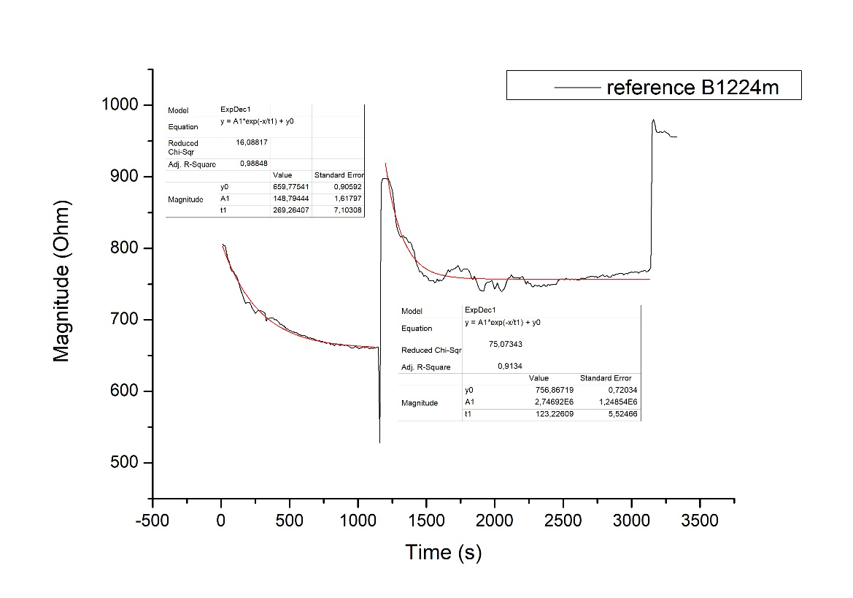
$$τ_{1}$$ | 269
$$τ_{2}$$ | 123
$$τ_{3}$$ | --

Reference fitting B1424a
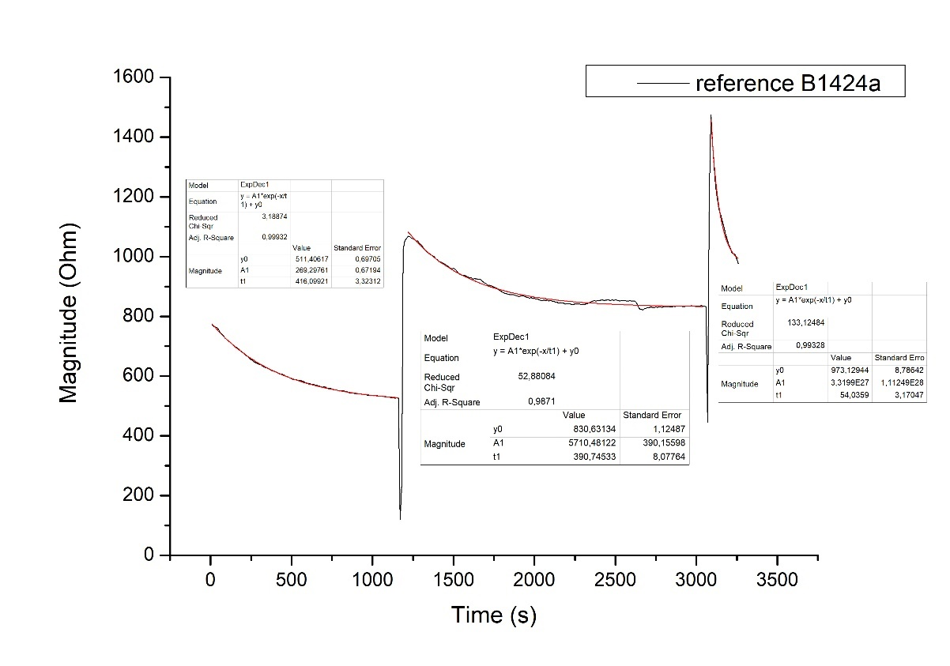
$$τ_{1}$$ | 416
$$τ_{2}$$ | 391
$$τ_{3}$$ | 54

Summary
$$τ_{1}$$ | 403 ± 116
$$τ_{2}$$ | 333 ± 145
$$τ_{3}$$ | 57 ± 23

PANI sensor fitting B322a
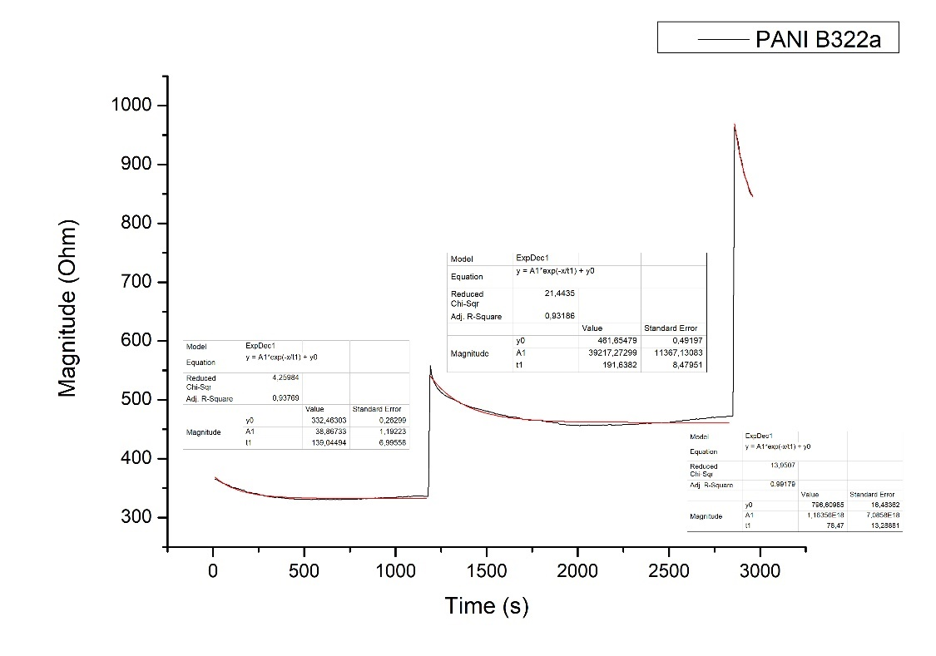
$$τ_{1}$$ | 139
$$τ_{2}$$ | 192
$$τ_{3}$$ | 78

PANI sensor fitting B423m
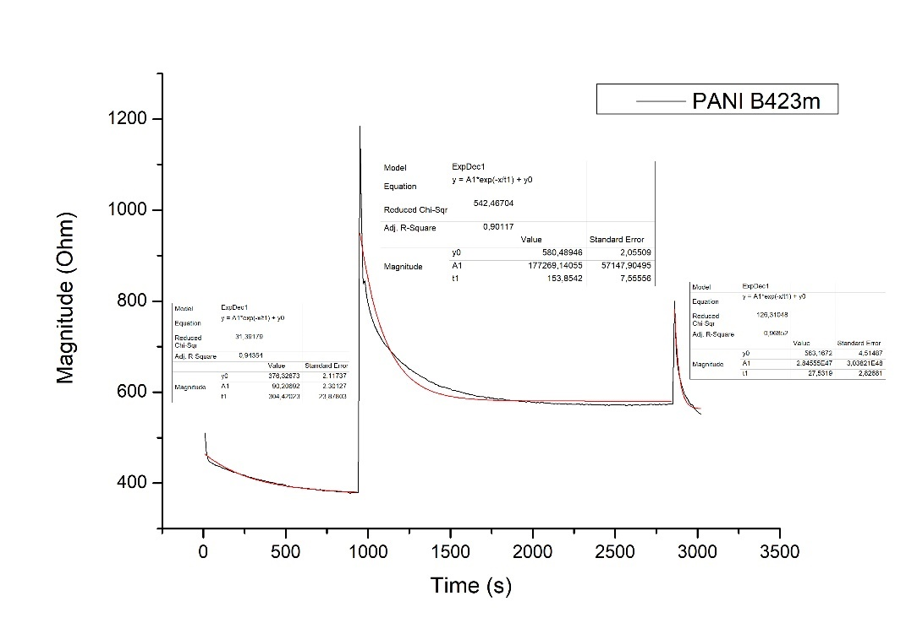
$$τ_{1}$$ | 304
$$τ_{2}$$ | 154
$$τ_{3}$$ | 27

PANI sensor fitting B623m
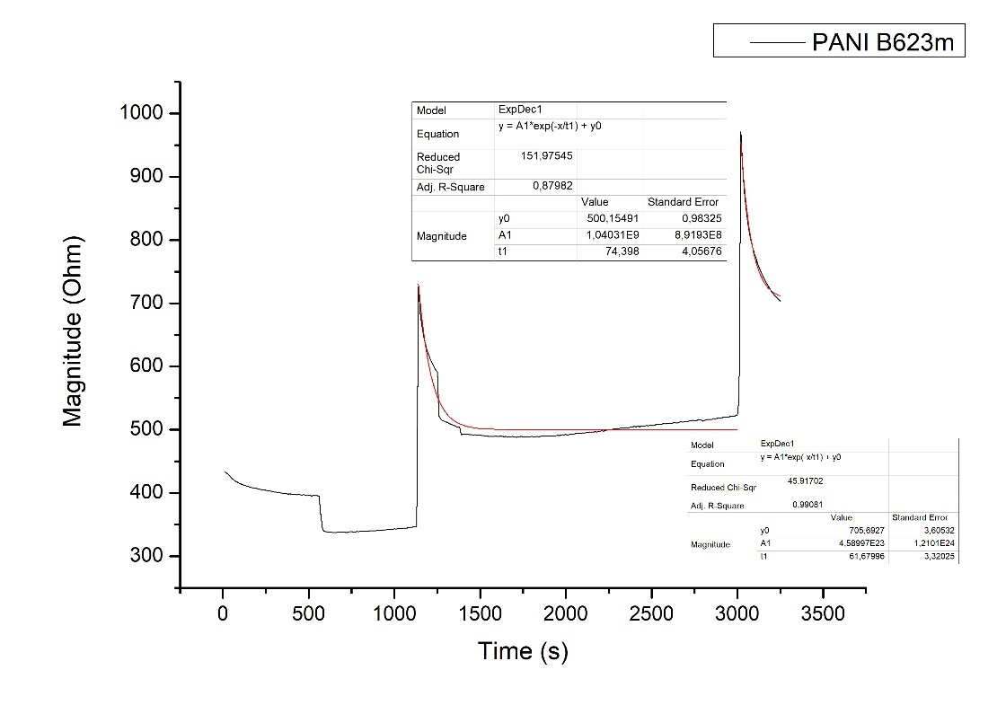
$$τ_{1}$$ | --
$$τ_{2}$$ | 74
$$τ_{3}$$ | 62

PANI sensor fitting B823a
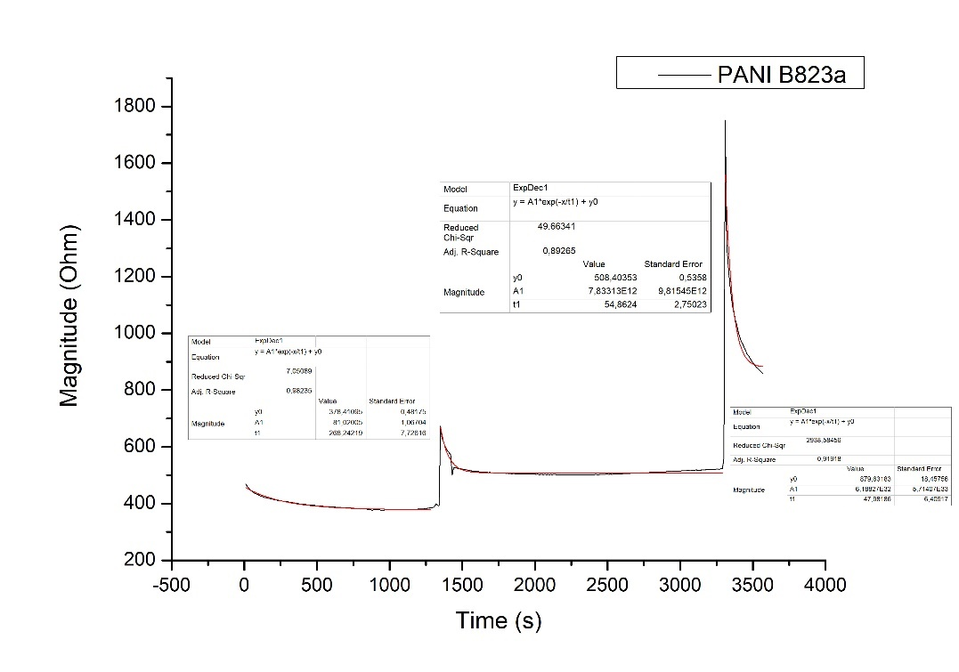
$$τ_{1}$$ | 268
$$τ_{2}$$ | 55
$$τ_{3}$$ | 48

PANI sensor fitting B1024m
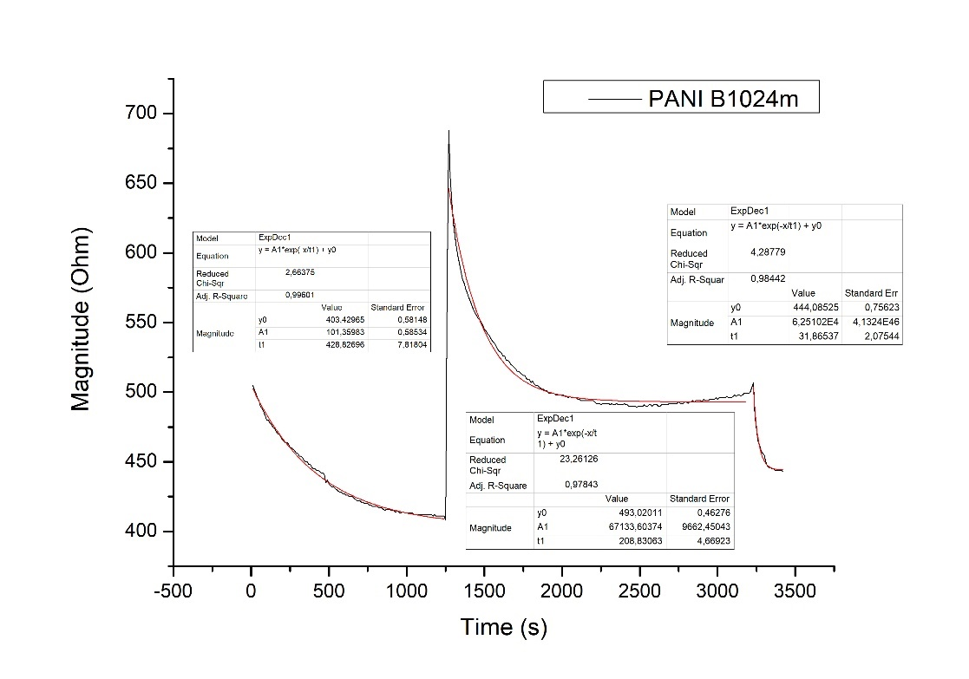
$$τ_{1}$$ | 429
$$τ_{2}$$ | 209
$$τ_{3}$$ | 32

PANI sensor fitting B1224m
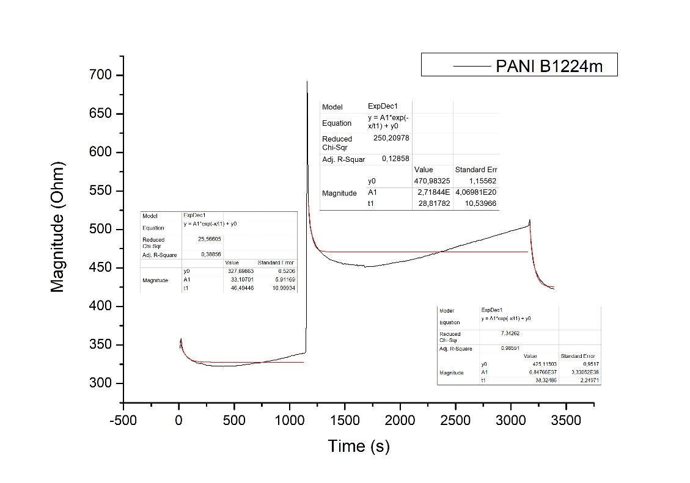
$$τ_{1}$$ | 46
$$τ_{2}$$ | 29
$$τ_{3}$$ | 38

PANI sensor fitting B1424a
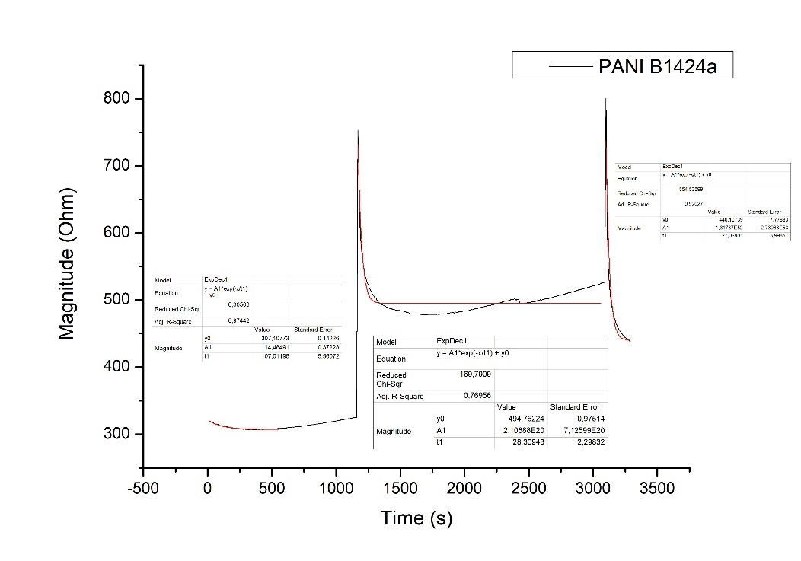
$$τ_{1}$$ | 107
$$τ_{2}$$ | 28
$$τ_{3}$$ | 27

Summary
$$τ_{1}$$ | 216 ± 143
$$τ_{2}$$ | 106 ± 77
$$τ_{3}$$ | 45 ± 19

Comparison Recipes B
B322a B423m
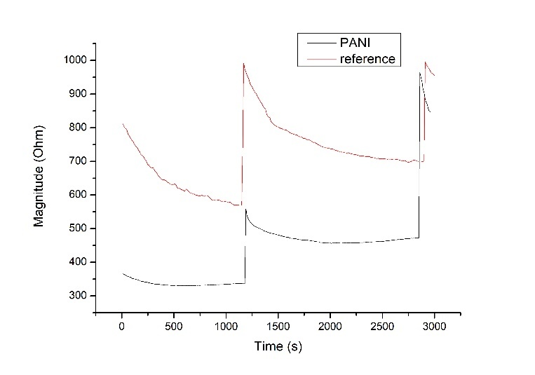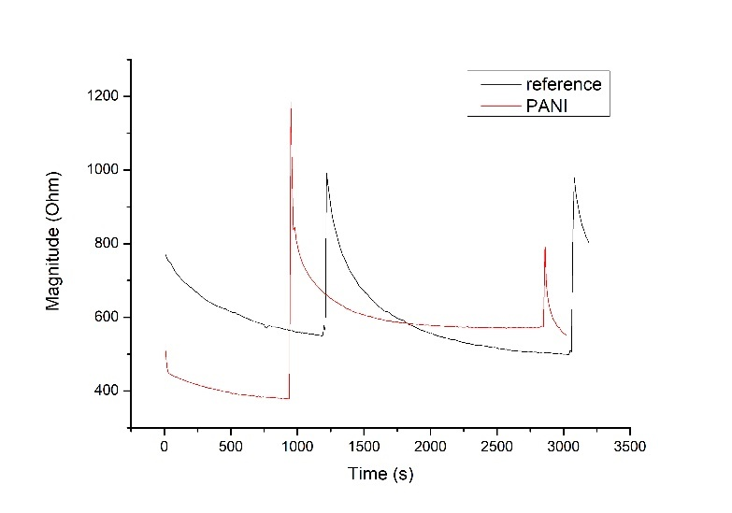

B623m B823a
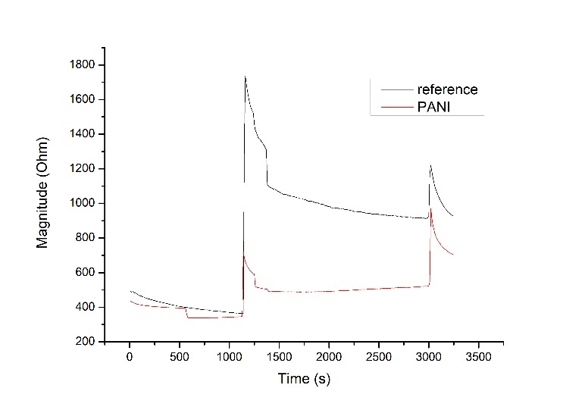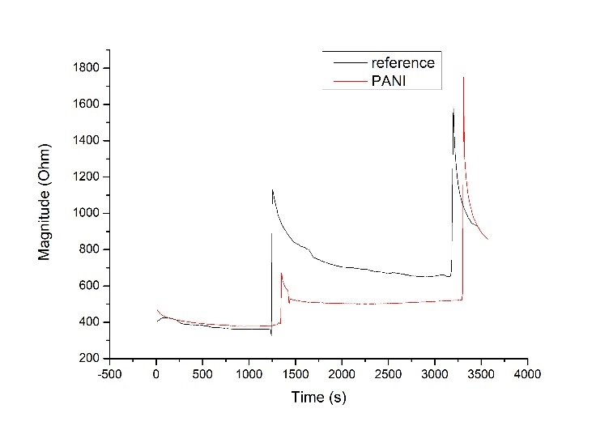

B1024m B1224m
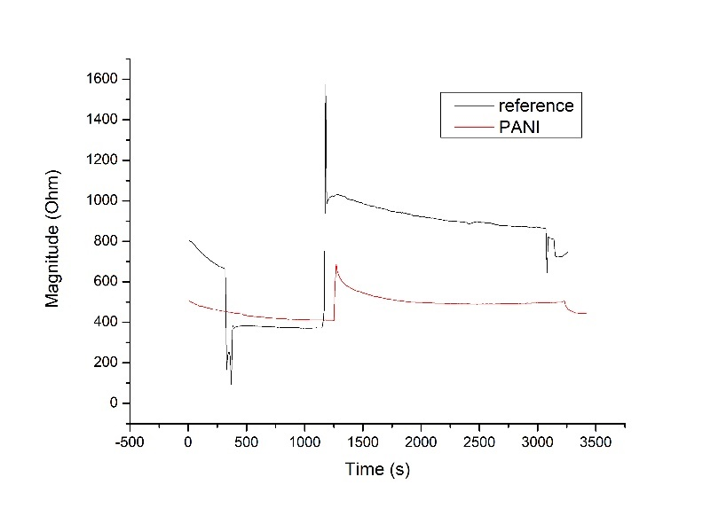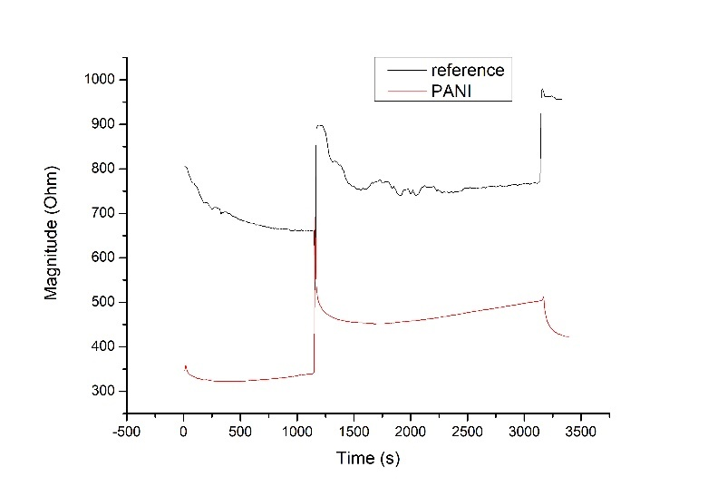

B1424a
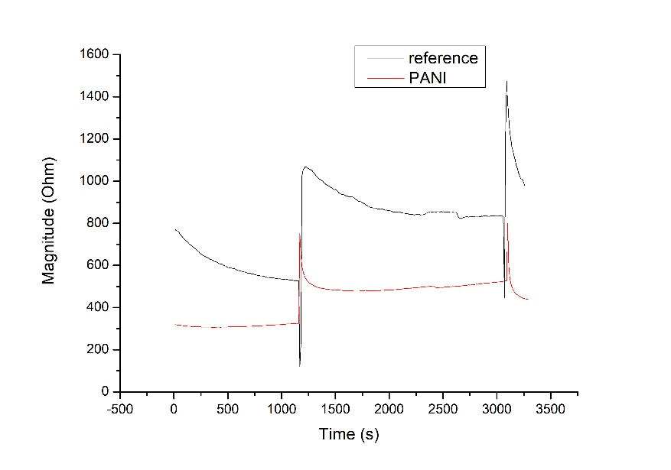

Magnitude trend of sensors for recipe B
This graph is obtained calculating the average of every linear part of the graphs corresponding of a stable signal for the impedance measurements. BF: bulk fermentation, P: portioning, AF: after fermentation.

Recipe | Bulk fermentation |  | Portioning |  | After fermentation
 | reference | PANI | reference | PANI | reference | PANI
B322a | 580 ± 8 | 333 ± 2 | 702 ± 3 | 462 ± 5 | 956 ± 2 | 848 ± 1
B423m | 554 ± 3 | 382 ± 2 | 506 ± 5 | 573 ± 2 | 810 ± 8 | 554 ± 3
B623m | 375 ± 7 | 342 ± 2 | 923 ± 7 | 511 ± 6 | 934 ± 4 | 706 ± 3
B823a | 362 ± 1 | 380 ± 2 | 654 ± 4 | 513 ± 6 | 934 ± 3 | 862 ± 5
B1024m | 373 ± 1 | 411 ± 1 | 881 ± 10 | 494 ± 3 | 742 ± 3 | 444 ± 1
B1224m | 662 ± 1 | 330 ± 5 | 762 ± 4 | 491 ± 8 | 959 ± 3 | 424 ± 1
B1424a | 535 ± 5 | 323 ± 2 | 833 ± 2 | 510 ± 9 | 999 ± 15 | 441 ± 2

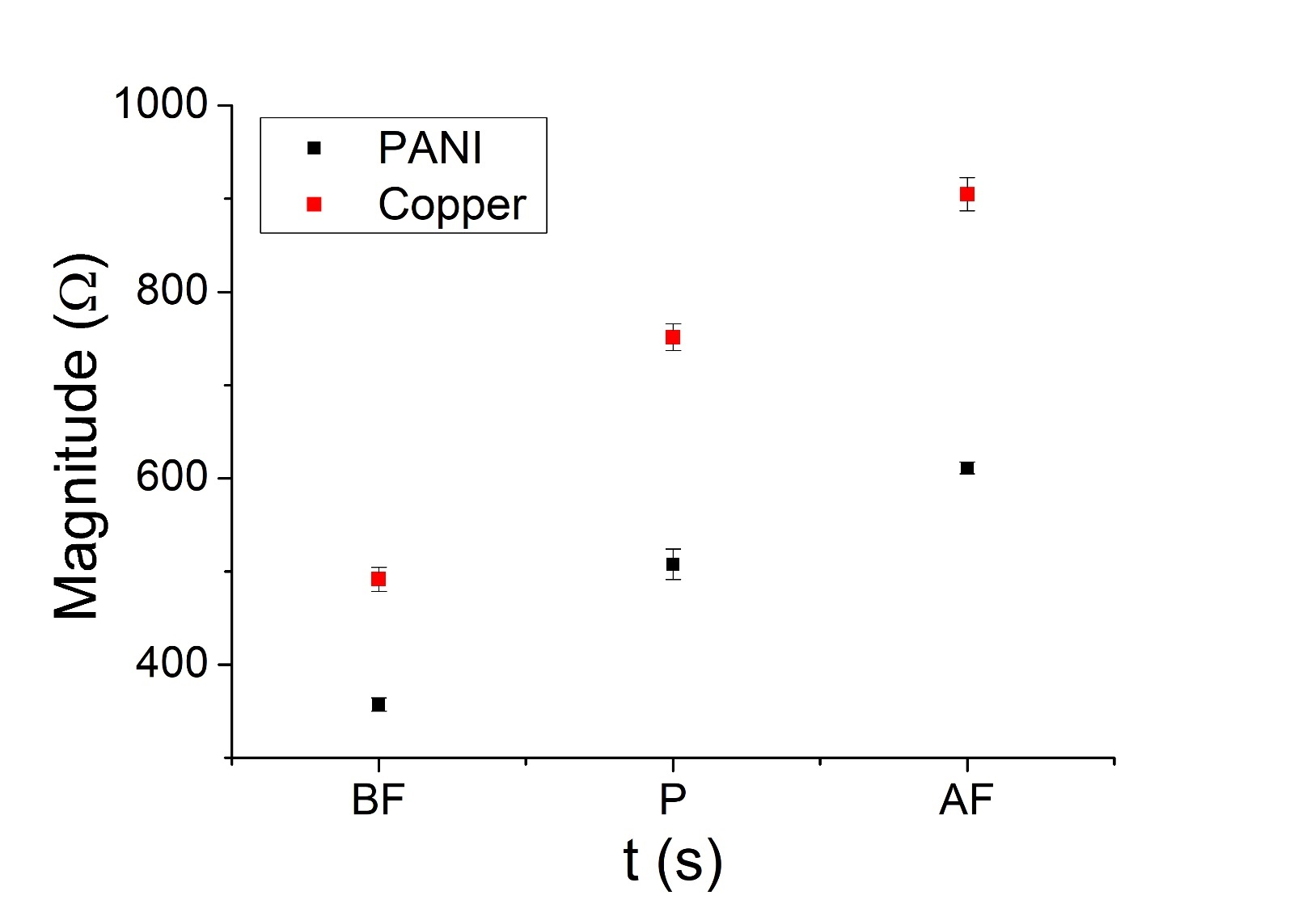

Continuous measurements

We peformed also continuous measurements on every recipe. Briefly, we put on 2 sensors (PANI sensor and the reference) a dough during the first step (bulk portioning), and left them for all the fermentation period until the dough has to be put in the oven, measuring continuously the impedance. Also in these cases, every curve was fitted with an exponential fitting to calculate the response time of the respective sensor. The results that we obtained are described below.

B322a B423m
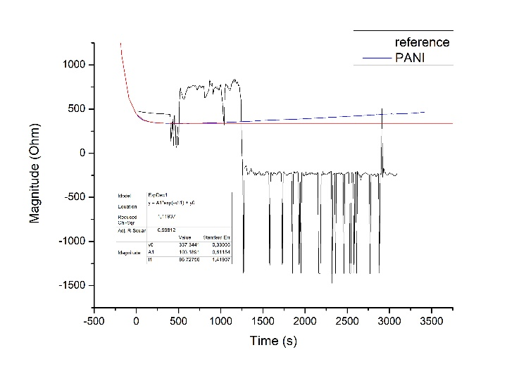
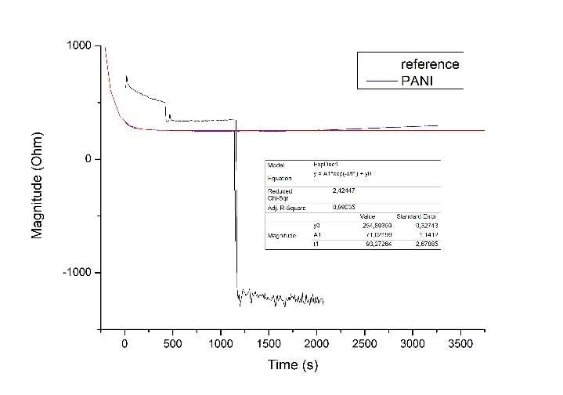
τreference | --
τPANI | 87
τreference | --
τPANI | 93

Note: Both in the analysis for the recipes above, the connections of the reference electrodes gave problems. It was impossible to fit the data.

B623m B823a
τreference | 266
τPANI | 70
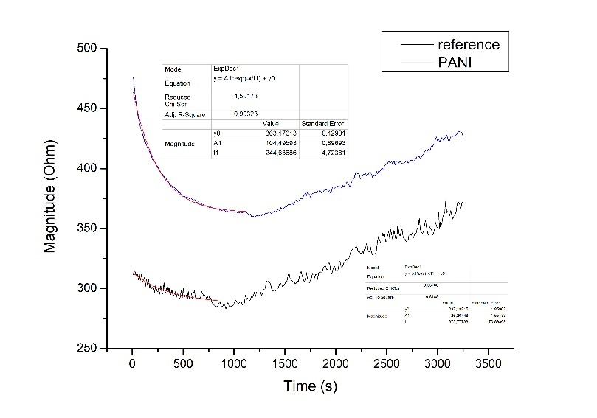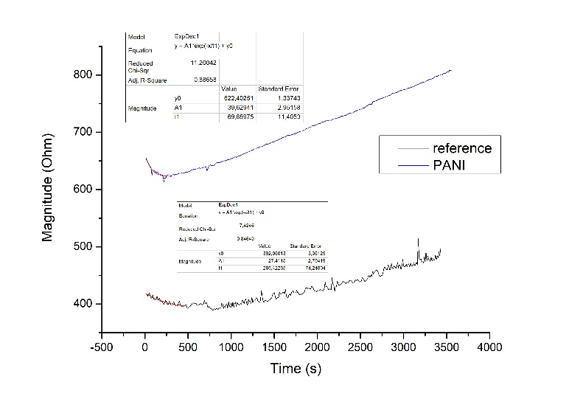
τreference | 374
τPANI | 245

B1024m B1224m
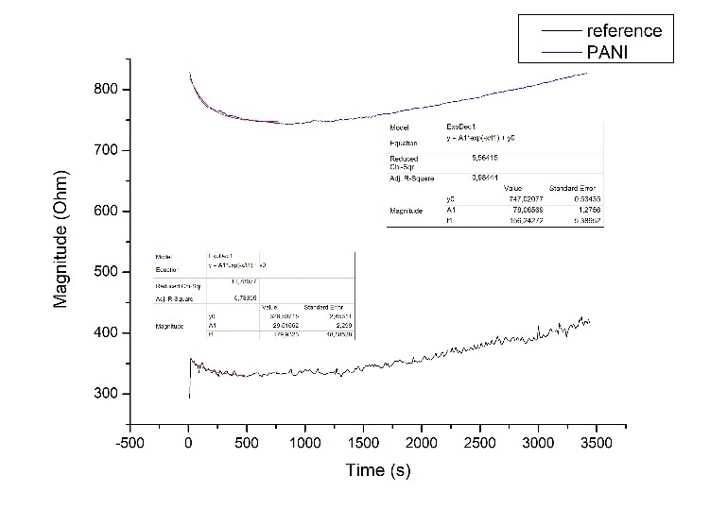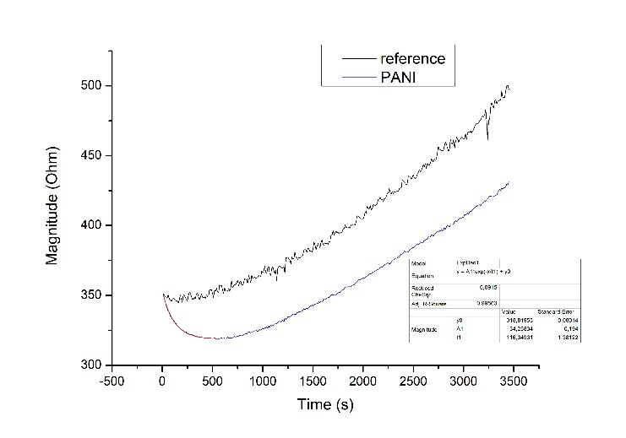
τreference | 179
τPANI | 156
τreference | --
τPANI | 116

B1424a
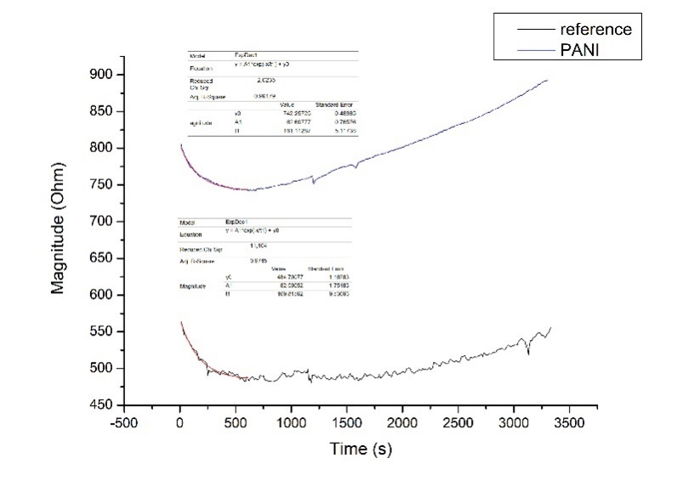
τreference | 170
τPANI | 161

τreference | 247 ± 45
τPANI | 133 ± 60
Summary

Mistakes of production

In order to evaluate if the sensors could be used also to monitor possible mistakes during the production of Semmelis, two recipes, in particular A1324a and B1224m were left overfermentating, respectively for 2 hours and 4,5 hours. After that, we performed some impedance analysis.
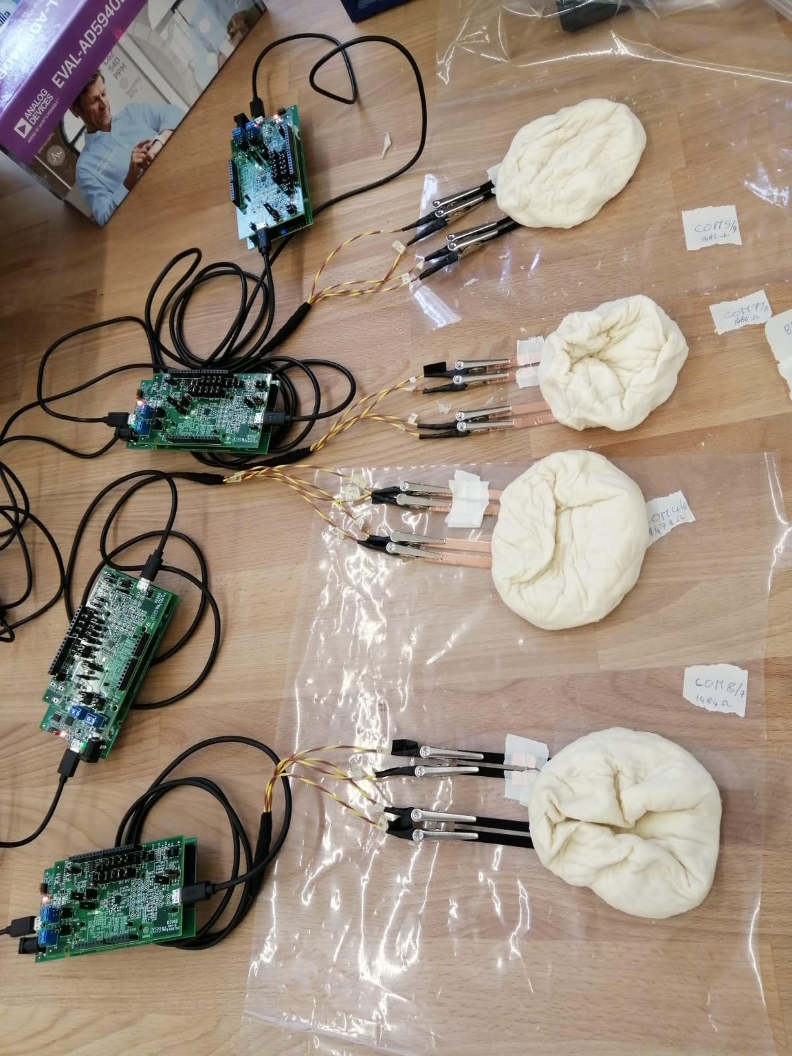
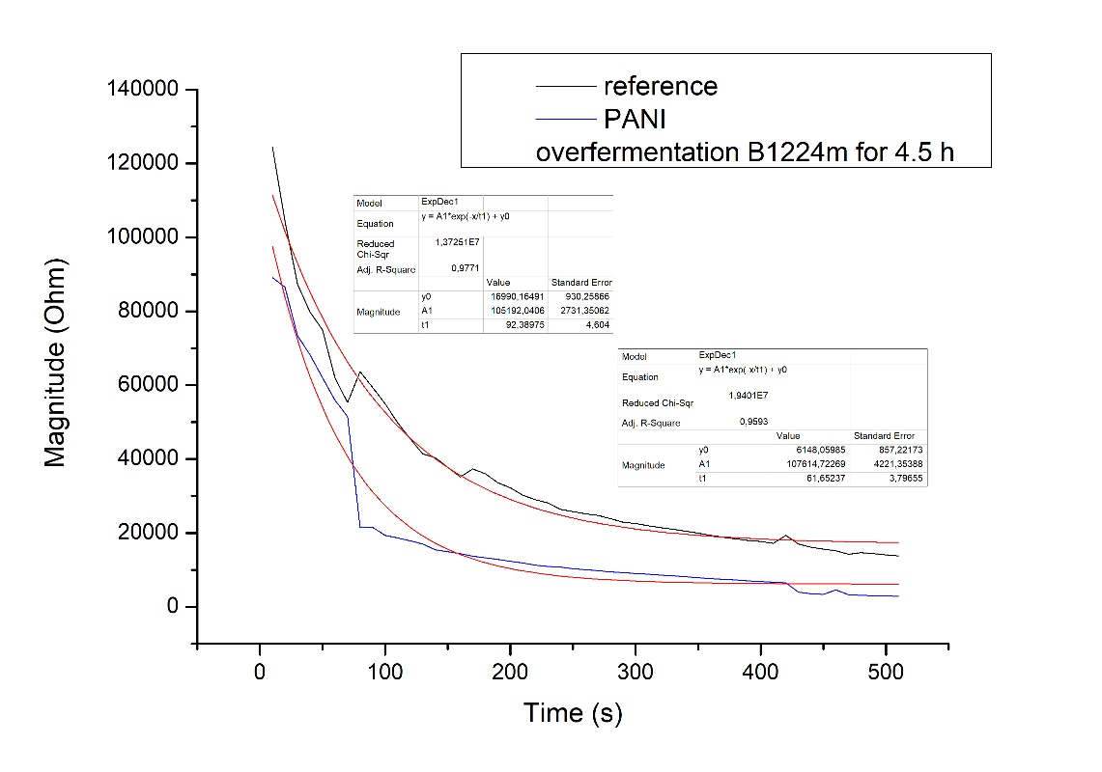
τreference | 92
τPANI | 61

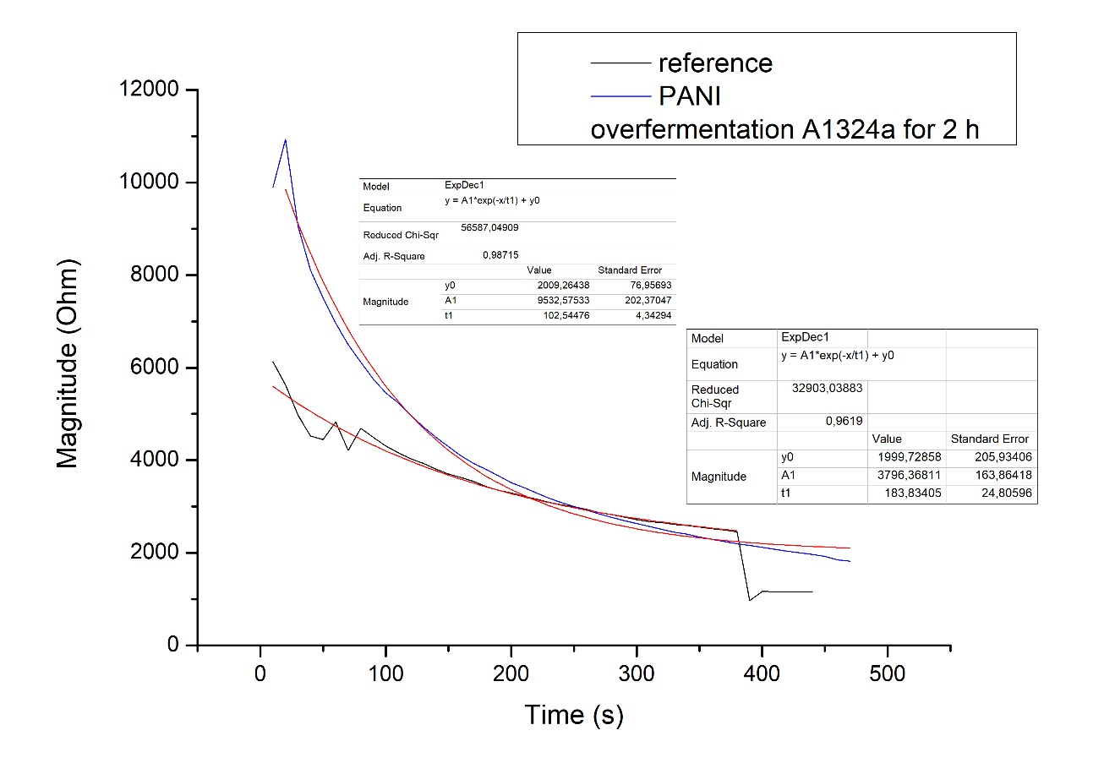
τreference | 183
τPANI | 102

